CSIS 4495 - Section 071

Applied Research Project

Oct 25, 2025 - Sep 08, 2025

Instructor

Bambang Sarif

Douglas College

**World Rebalance**

**Project Midterm Report**

A multiplayer game project with backend integration and real-time analytics

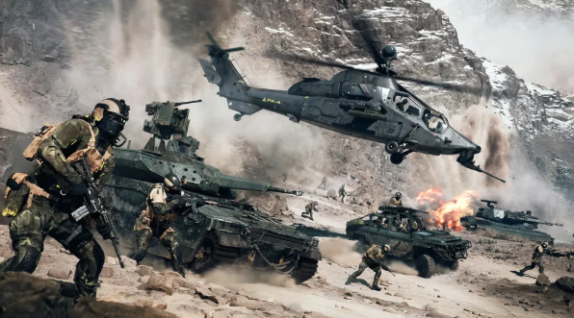

Pic1



Group

Hao SUO - 300392463

Yaolong Liu - 300380547

Muye Li - 300388453

Lead Contact

Yaolong Liu

liuy122@student.douglascollege.ca

+1 263-978-5806

**Introduction 3**

**Scope 4**

**Methodology 4**

**Justification of Methodology 4**

**Expected Results 5**

**Timeline 5**

**Deliverables 6**

Muye Li 6

Hao SUO 6

YaolongLiu 7

**Implemented Feature 1: Website Portal (Player Statistics Dashboard) 8**

Overview 8

Implemented Features 8

Screenshots and Descriptions 8

Technical Implementation 9

**Implemented Feature 2: Website Portal (Vehicle Performance Page) 11**

Overview 11

Implemented Features 11

Screenshots and Descriptions 11

Technical Implementation 12

**Implemented Feature 3: Backend data analysis program 13**

Overview 13

Implemented Features 13

Screenshots and Descriptions 13

**Project Contract 16**

**Work Logs 17**

Hao SUO 17

Yaolong Liu 17

Muye Li 19

**Implemented Feature 4: Game Project 21**

Overview 21

**Game Concept 21**

**Our Mod 25**

**Game Mechanism 26**

**Game Project 26**

Open our Game project: 26

Code and Blueprint 30

Player code and Blueprint: 30

Tank code and Blueprint: 41

Maps in the Editor 44

Play our Game 45

In Unreal Editor: 45

In the Build Output: 47

**Reference 51**

**Appendix 52**

1 Applied Research Report Using Chart.js 52

2 Applied Research report interaction with Chart.js 52

# Introduction

We are developing a multiplayer game for our CSIS 4495 Applied Research Project. We have divided the project into three major parts: the game itself, the game backend, and the website portal.

We are creating *World Rebalance*, an online first-person shooter multiplayer game inspired by the worldview of *Command and Conquer 3*. Players can choose between two camps (GDI and Nod). In the game, we allow players to buy new weapons and vehicles to defeat enemies and achieve victory. Each camp will include three types of vehicles: assault vehicles, scout vehicles, combat tanks, and special high-end vehicles. For now, we will focus on developing one map, but if all core mechanisms are completed, we plan to add more selectable maps. After each battle, we will generate gameplay data such as kills, wins, time spent, vehicle usage, and payments through the backend.

We have observed that most games only provide in-game statistics, lacking detailed post-game analysis for players and stakeholders. Although some popular online games, such as *World of Warcraft* and *League of Legends*, provide websites where players can view statistics, these platforms are often limited in scope. For example, Blizzard provides an online portal for game statistics, but it only shows limited data and updates are often delayed. Similarly, Riot Games offers match history for *League of Legends*, but players cannot customize or compare data outside the built-in system. These limitations highlight a research gap: the lack of a real-time external analytics portal that allows players to access and compare gameplay data more flexibly.

The purpose of our project is to design and implement such a portal, which will provide players and stakeholders with clear and interactive access to game statistics, performance indicators, and comparative data. We assume that our platform will be able to perform real-time analysis of match data and provide live player rankings.

**Objectives**

Our objectives are to enable players to access game statistics such as win rates, kill/death ratio, and total playtime without logging into the game itself.  
We aim to provide data analysis and visualization on the website so that users can better understand their performance trends and gameplay history.  
In addition, we plan to allow users to search and filter information related to other players, matches, or vehicle data through interactive web components.  
We also intend to implement a user login system with secure authentication to ensure controlled access to personalized features.

At the current stage of the project, we have already developed the Player Statistics Dashboard and the Vehicle Performance Page within the website portal. These pages demonstrate our progress toward achieving the main objectives of data access, visualization, and interactivity. The basic database structure and connection between PHP and MySQL have also been completed, and simulated data are being used to test the visualization features.

# Scope

* We designed and created a MySQL database to store player and vehicle statistics. (completed)
* We developed PHP scripts to retrieve, process, and display gameplay data from the database. (completed)
* We implemented interactive data visualization using Chart.js to present win rates and K/D ratios. (completed)
* We added search and filter functions on the Player and Vehicle pages for data exploration. (completed)
* We used simulated data to test the website features while waiting for real backend integration. (in progress)
* We will connect the portal to the backend API once the gameplay data pipeline is available. (planned)
* We plan to implement PHP session management and access control to handle user authentication and protect restricted pages. (planned)

# Methodology

We are building our online multiplayer first-person shooter in Unreal Engine 5 using C++ and Blueprints, and we are integrating it with Steam services. The game will support both server hosting and joining. Once all players have joined a skirmish, they will be able to choose a faction before entering the battle. When the game ends, we will read the log file from the host and asynchronously POST the data to the server through FHttpModule.

For each game, we will store players’ performance data in a database, and we will use this data to train models that evaluate both overall player performance and vehicle-specific performance. We also plan to train models to determine whether certain vehicles are too powerful or too weak. These models will be retrained once a day, and performance will be evaluated when the backend program receives requests from the website.

We will connect the website to the backend API that we are developing. We will use PHP to request and process the data, and we will set up a MySQL database to store it. Our main focus will be presenting the information in tables and charts, and we plan to use a JavaScript library such as Chart.js for visualization. Finally, we will deploy the site on a simple cloud platform so that it can be accessed during testing and presentation.

# Justification of Methodology

We chose PHP and MySQL because we already learned them in our previous courses, and our team is more familiar with them. PHP is simple to use for building a website, and MySQL is a database for storing game data. Using these two together also makes the project easier to finish within the time limit.

For data visualization, we plan to use Chart.js. This library is good for making interactive charts and can update data in real time. Since our project is about showing match results and player rankings, Chart.js fits with our goals well.

For data analysis, we choose python. We will use models in scikit-learn library. This library is an open-source Python library that provides simple and efficient tools for data mining and machine learning.

We will also deploy the system on a simple cloud platform. This makes the website easier to test and show to others, because it can be accessed from anywhere, not only one computer. We also plan to use Firebase authentication, so that users can log in safely and access their own data.

# Expected Results

A stable running multiplayer game. Minimum 10 players could run at the same time. Tracking and output data by players’ actions. Combat functions and purchasing systems are reliable.

The expected result of this project is a web portal that can connect to the backend and show real-time gameplay statistics. It will also provide interactive charts and live player rankings, so players can easily access and compare their game performance.

# Timeline

The Gantt chart below illustrates the project timeline up to the midterm stage, showing the planned start dates, durations, and completion status of major tasks in the game development.

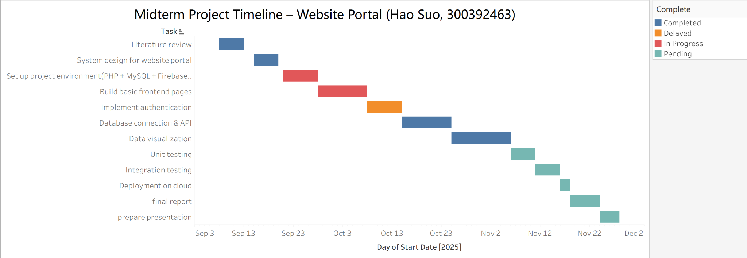

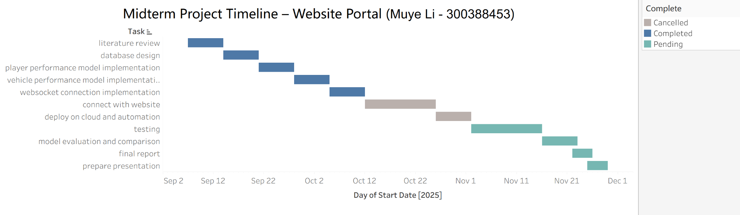

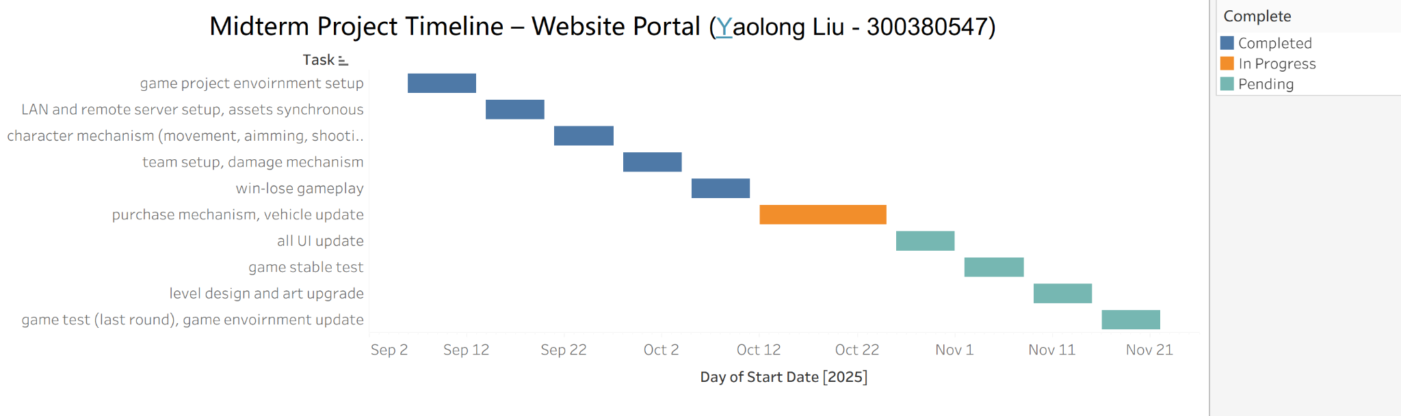

# Deliverables

## Muye Li

| 9/21 | Create a local database and generate data tables. |
| --- | --- |
| 10/5 | Finish two models’ code, ability to evaluate user and vehicle performance through game recording training. |
| 10/26 | Finish connect to website and game, put the game records into MySQL database, receive web page requests and return data, product API documents. Create midterm report and midterm video. |
| 11/2 | Deploy programs on cloud. |
| 11/16 | Linkage test documentation files. Create test documentation files. |
| 11/22 | Complete the model evaluation document. |
| 11/29 | Complete final report. |

## Hao SUO

| Sep 18 | System Design | System architecture diagram/use case diagram with descriptions |
| --- | --- | --- |
| Sep 25 | Environment Setup | Configured PHP + MySQL environment/environment setup report with screenshots |
| Oct 3 | Basic Frontend Development | Prototype report |
| Oct 12 | User Authentication | User registration and login functions, session management, password hashing and input validation |
| Oct 19 | Database & API | Database connection, basic CRUD API endpoints, test screenshots showing data retrieval |
| Oct 29 | Data Visualization | 2–3 interactive charts (win rate, K/D ratio, playtime) implemented with Chart.js; integrated frontend display pages |
| Nov 10 | Unit Testing | Test cases for modules, unit testing report (pass/fail results), repository includes test files |
| Nov 15 | Integration Testing | End-to-end testing (login → upload data → visualization); bug report and fixes; integration testing summary document |
| Nov 20 | Cloud Deployment | Website deployed on cloud platform (AWS/Heroku/Azure); deployment guide with screenshots |

## YaolongLiu

| 9/20 | Environment setup (confirm the version of the game engine, C++ software: Rider), multiplayer server raw project. |
| --- | --- |
| 9/27 | Raw playable project for a LAN server in our Douglas labs/ library.. |
| 10/4 | Log post to FHttpModule; A test for replicate assets with gameplay; Vehicle basic machinic. |
| 10/11 | Team setup; Basic win-lose condition. |
| 10/18 | Purchase for the unique vehicles and work well in the two camps. |
| 10/25 | First round of the whole test. |
| 11/1 | Environment upgrade. Level Design: a playable whitebox playground setup. |
| 11/8 | Level Art upgrade. Shader polish. Lab computers’ pressure test. |
| 11/15 | All UI and UX upgrades. |
| 11/22 | Final Test for all the performances. |
| 11/29 | Debug and Demo video. |

# Implemented Feature 1: Website Portal (Player Statistics Dashboard)

## Overview

The Player Statistics Dashboard is the first part we worked on for the website portal.  
It shows each player’s game performance, such as their kill/death ratio, win rate, and vehicle usage.  
We used PHP, MySQL, and Chart.js to build this page.  
When a user selects a player from the dropdown list, the charts automatically update to show that player’s data.

Currently, we are using simulated data for testing because the game backend is not ready yet.  
Later, when the API is completed, this page will connect to the real game data and display live results.

During development, we faced challenges with linking multiple charts together.  
This required carefully considering the business logic to ensure data consistency across charts.  
We also conducted research on Chart.js interaction methods, as shown in the appendix: Applied Research Report Using Chart.js.

## Implemented Features

* Added a player selection dropdown to choose which player’s data
* Created interactive charts using Chart.js to show kill/death ratio and win rate.
* Used PHP and MySQL to load player data from the database.
* Implemented real-time chart updates when users change the selected player.

## Screenshots and Descriptions

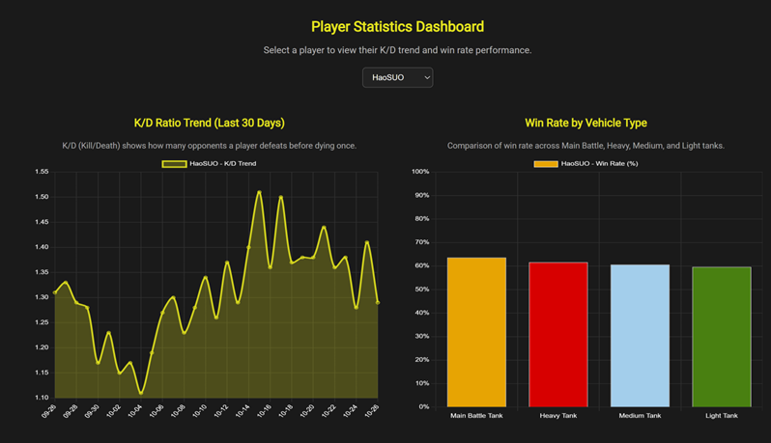

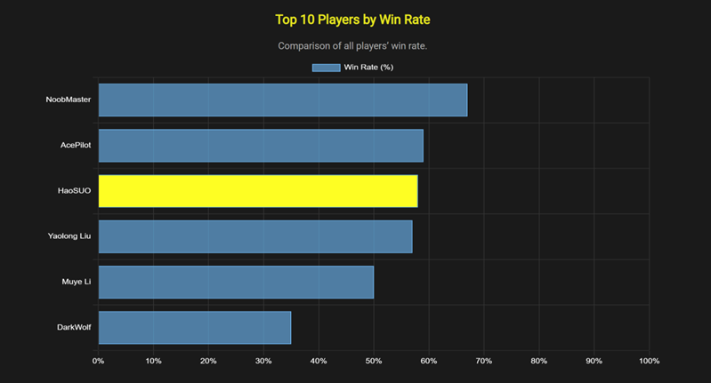

## Technical Implementation

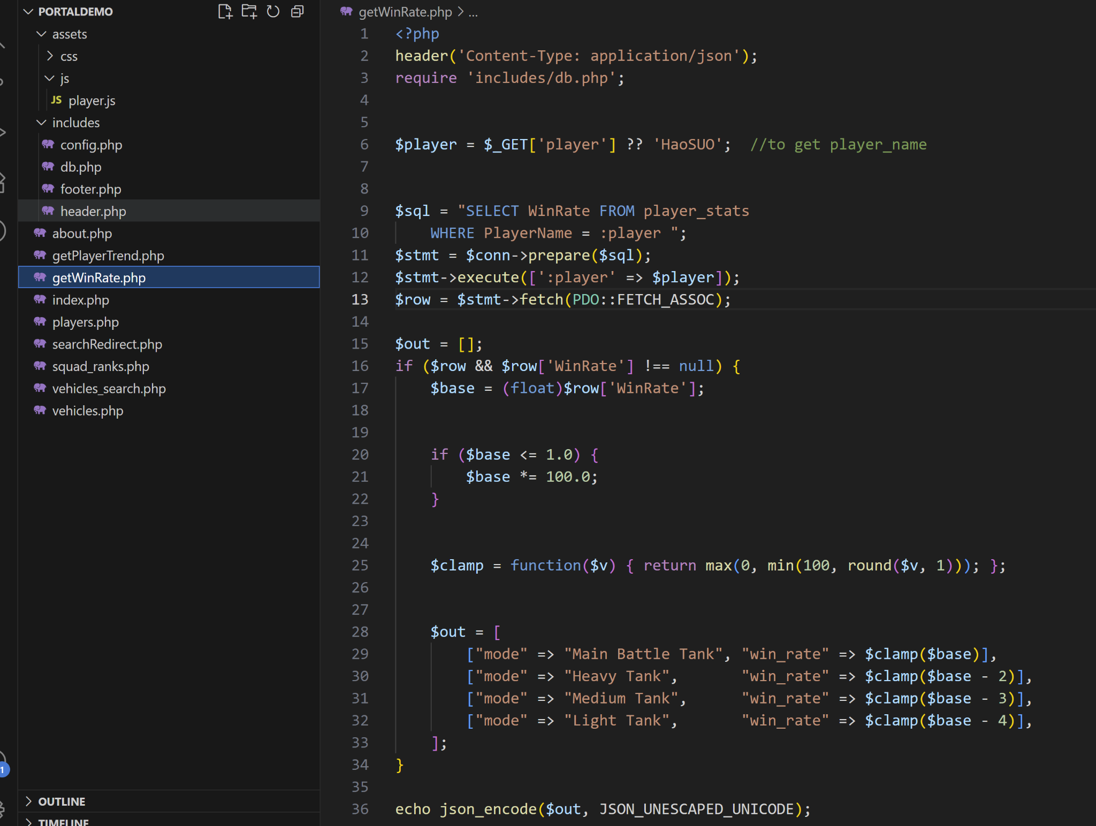

Figure 1 shows the PHP code that retrieves a player’s win rate from the database and returns the data as JSON for the frontend chart.

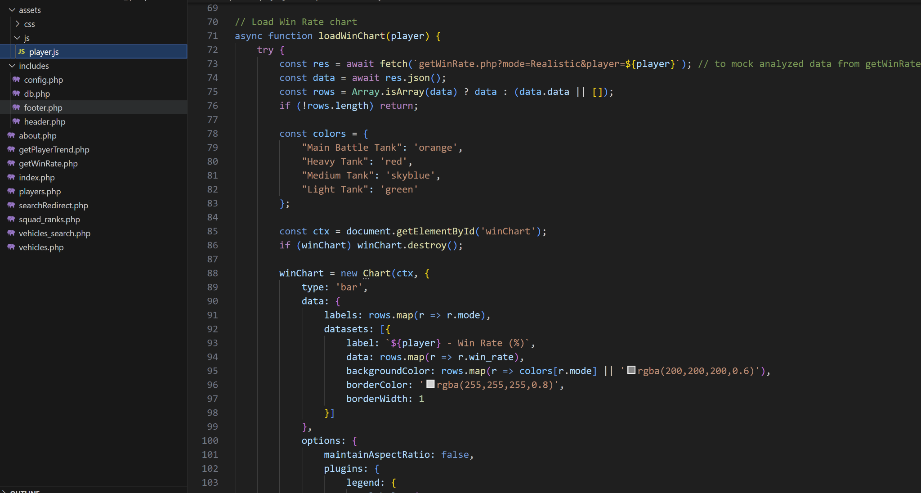

Figure 2 shows the JavaScript code that fetches player win rate data from the PHP API and uses Chart.js to draw a bar chart on the webpage.

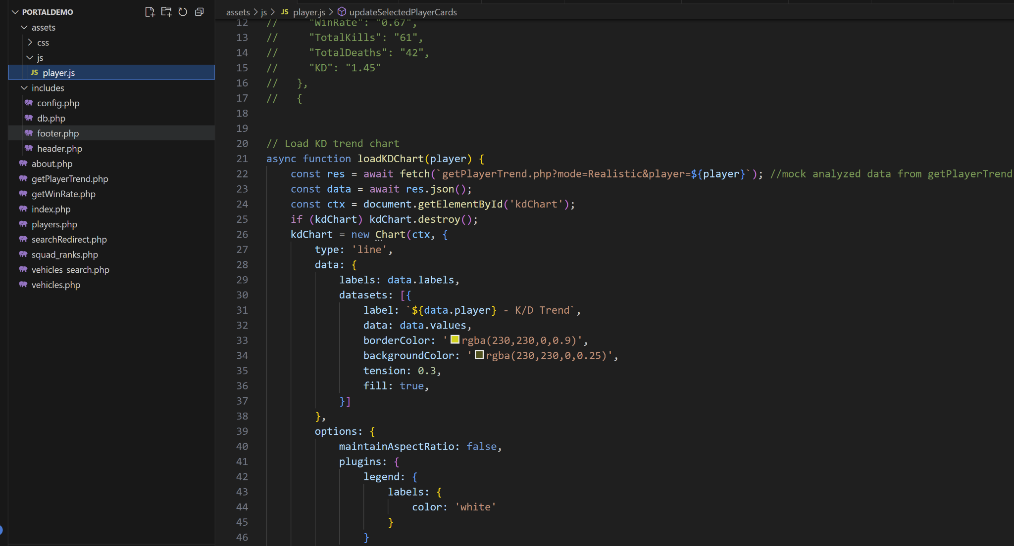

Figure 3 shows the JavaScript code that fetches player K/D ratio trend data from the backend and visualizes it as a line chart using Chart.js.

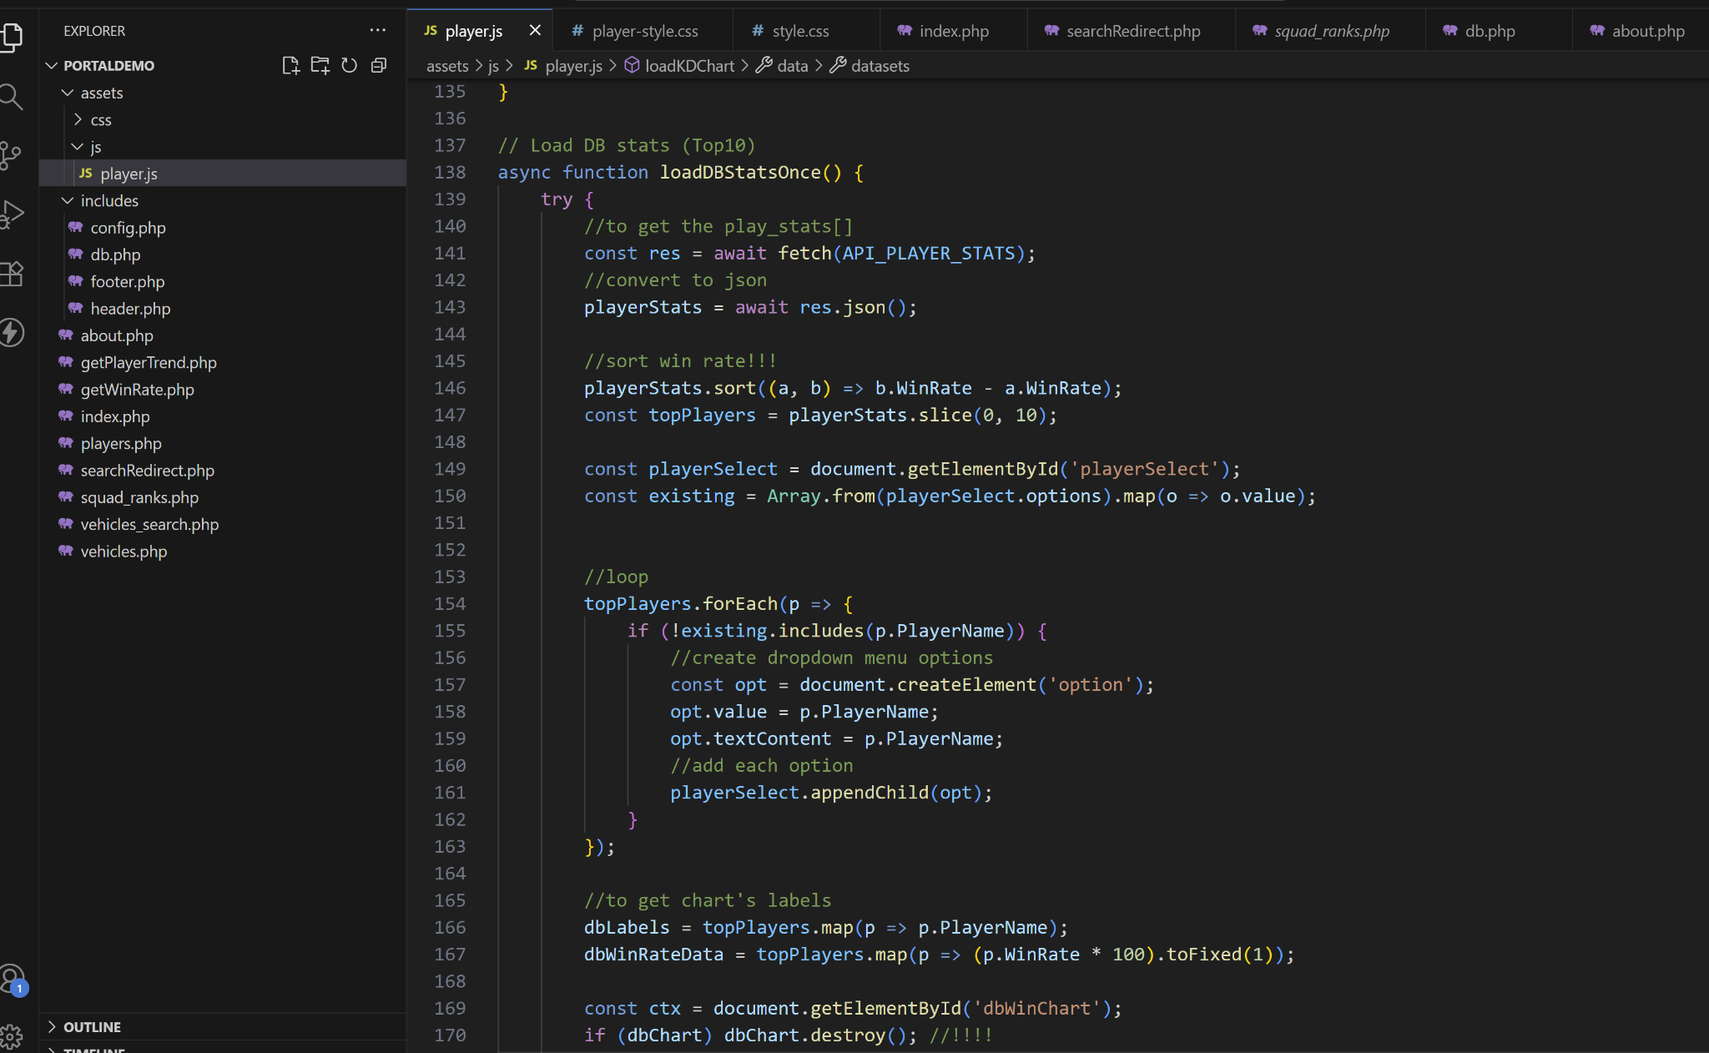

Figure 4 shows the JavaScript code that loads player statistics, fills the dropdown list with the top 10 players, and displays their win rates in a bar chart. The three charts on this page are linked through the player name, which is obtained at the start of each function based on the user’s current selection.

# Implemented Feature 2: Website Portal (Vehicle Performance Page)

## Overview

It shows how different vehicles perform in the game, including their win rates, matches played, and roles such as scout, tank, or assault vehicle.

This page helps players and developers compare which vehicles perform better or worse in battles.

The data are read from the database and Users can also use a search bar and filter options to find vehicles by name, country, or role.

Right now, the page uses simulated data for testing, and it will later connect to the real backend API once it’s ready.

## Implemented Features

* Displayed a vehicle performance table showing rank, name, country, role, matches played, wins, and win rate.
* Added a search bar that allows users to find vehicles by name or country.
* Included filter buttons to view vehicles by different roles such as assault, scout, or tank.
* Connected the page to a MySQL database through PHP to load data dynamically.

## Screenshots and Descriptions

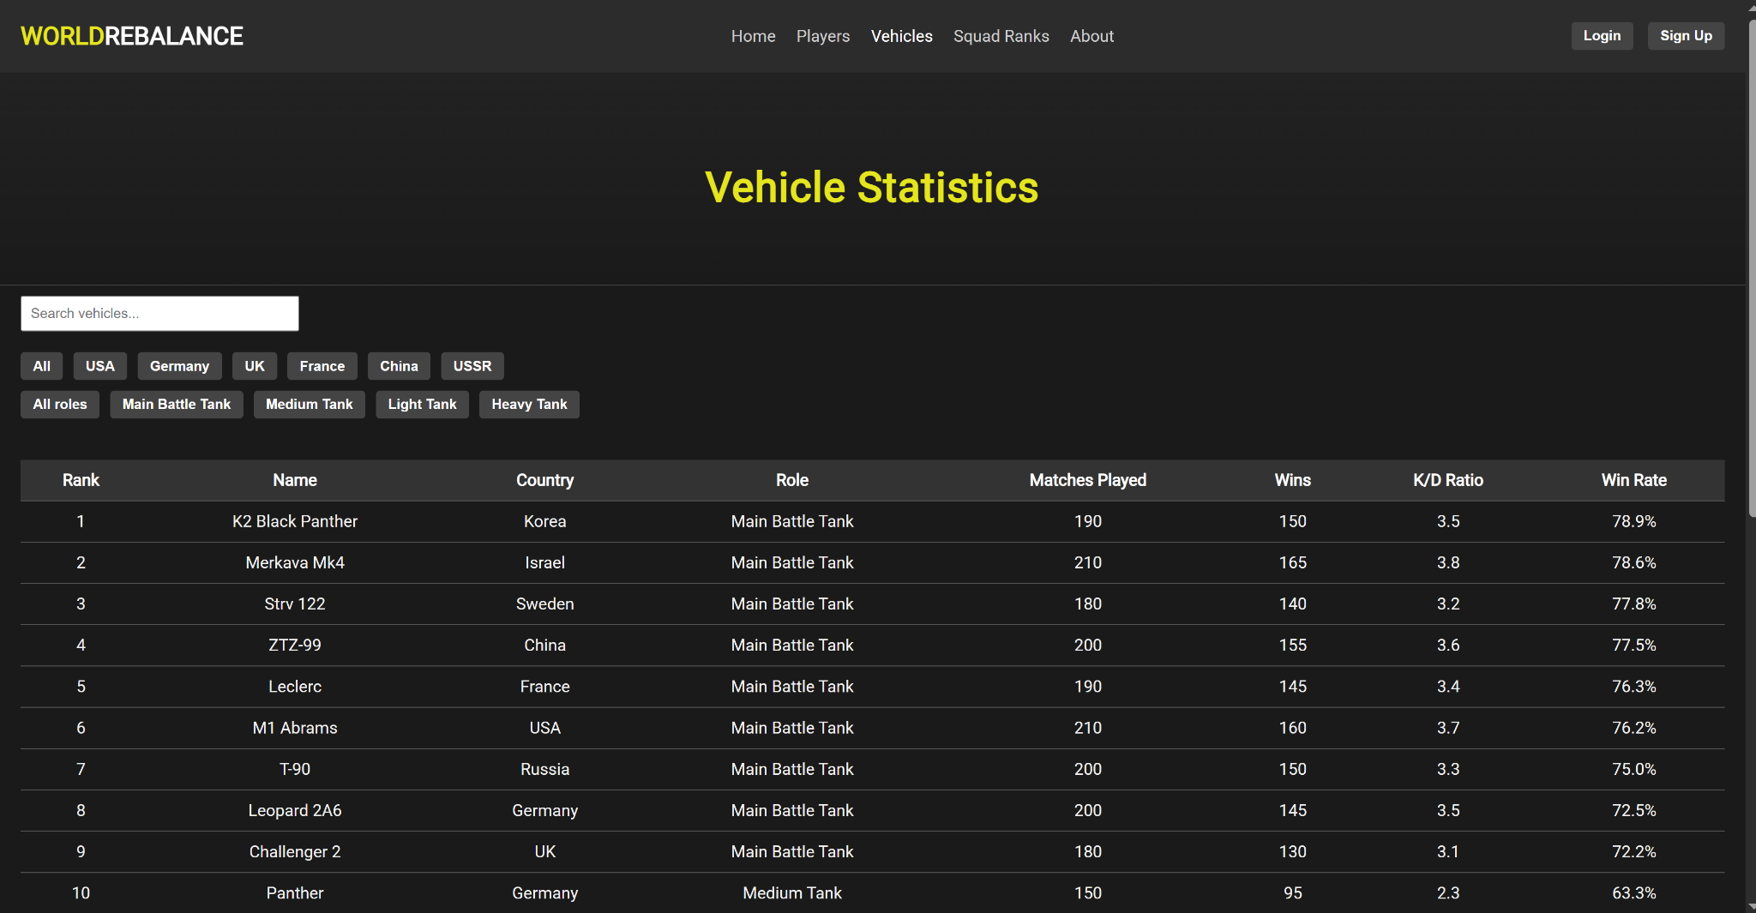

## Technical Implementation

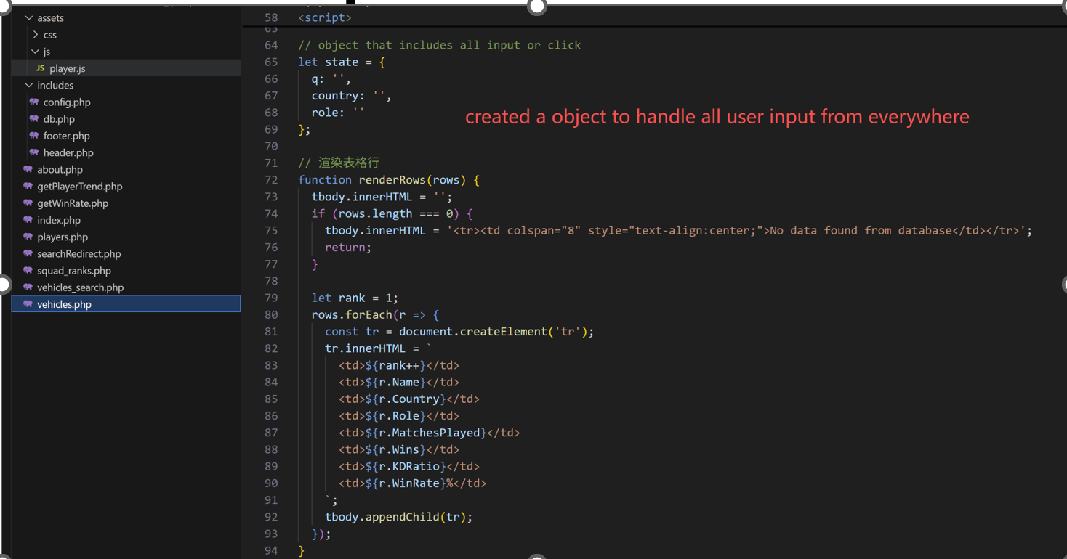

Figure 1 shows the JavaScript code that creates an object to handle all user inputs such as search and filters, and dynamically renders vehicle data into an HTML table.

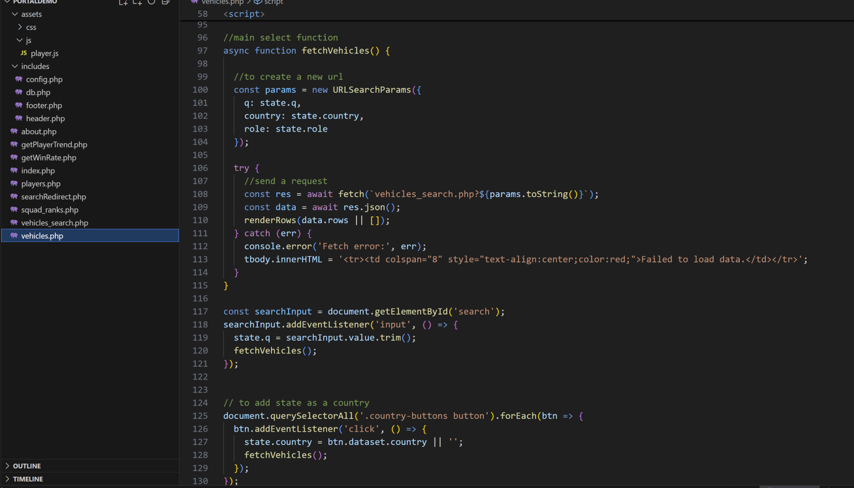

Figure 2 shows the main JavaScript function that uses the “input object” to build a query URL, sends a request to vehicles_search.php, and dynamically updates the table when users search or click filter buttons.

# Implemented Feature 3: Backend data analysis program

## Overview

Data analysis programs are background programs that obtain data by reading the game log files and store them in the database. Machine learning programs read data from the database once a day to train the model, and then generate vehicle and player performance data and store them in the database.

## Implemented Features

* Read data from log file.
* Read and store data from database.
* Train logistic regression model.
* Receive websocket and http request.

## Screenshots and Descriptions

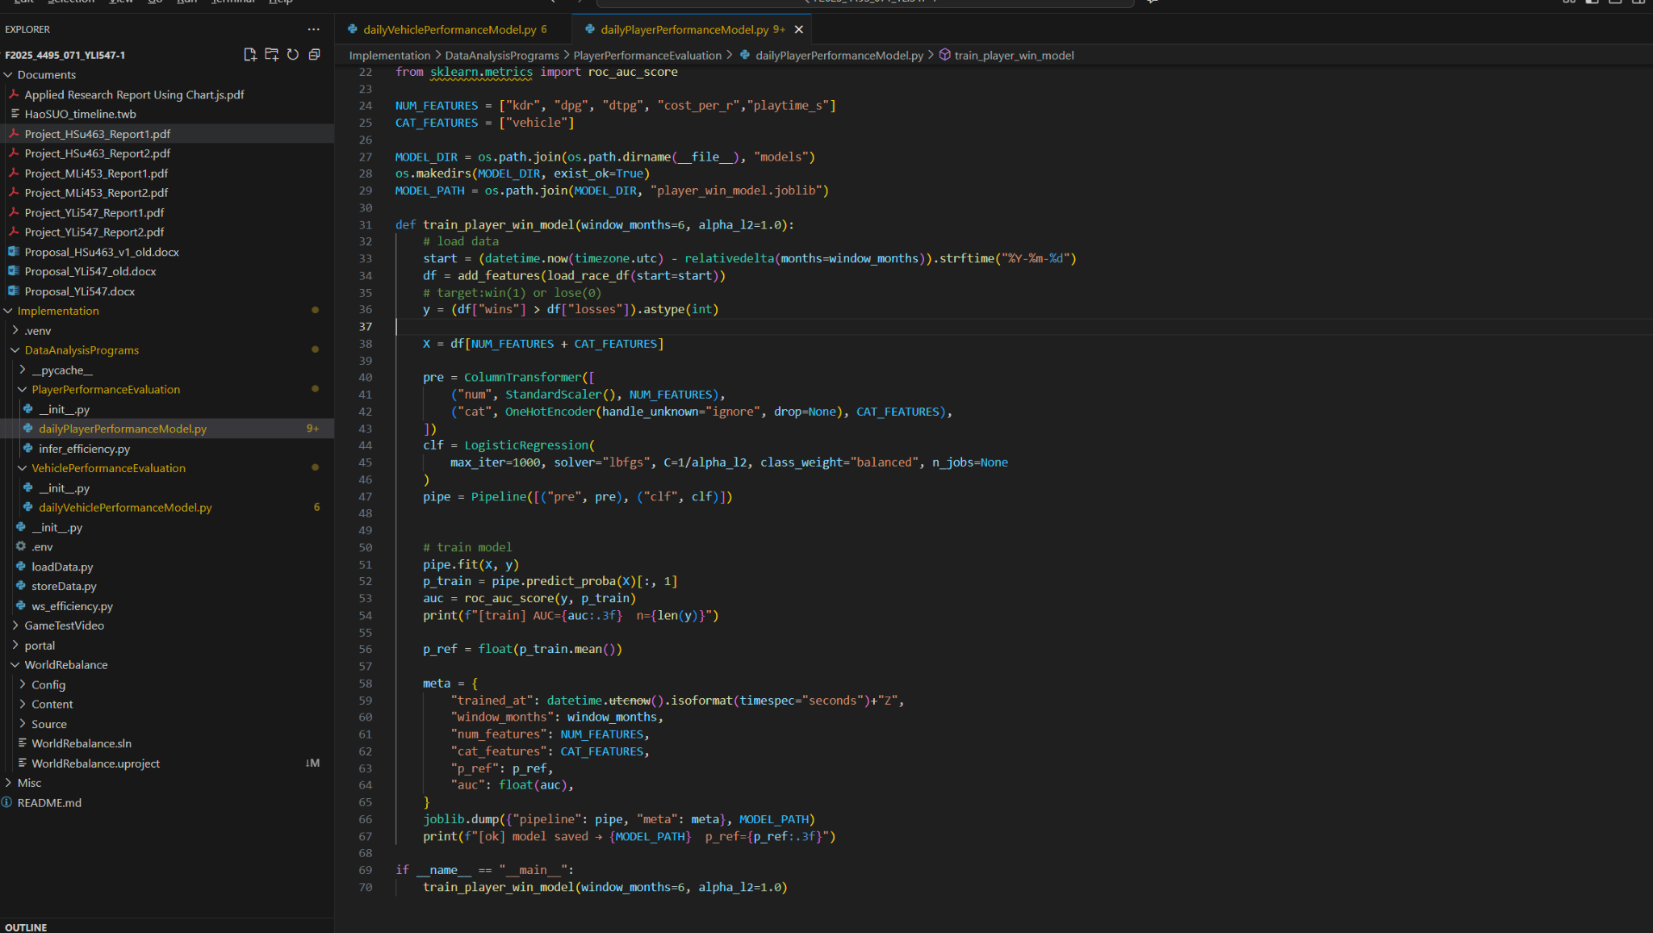

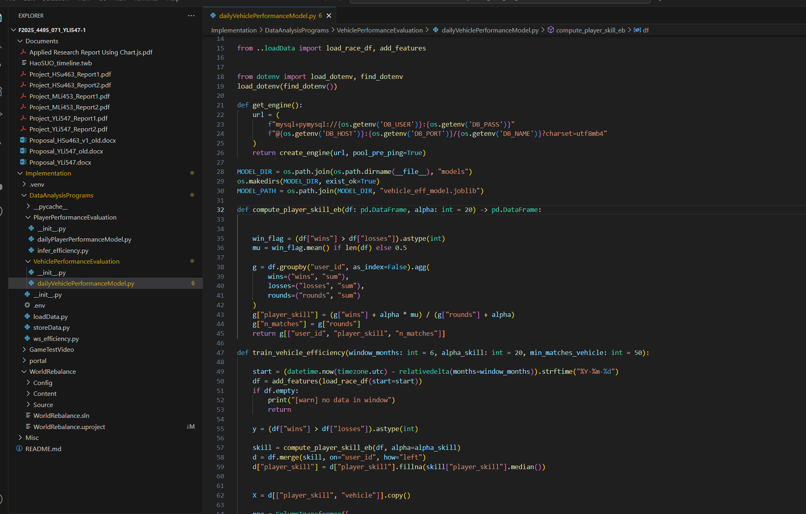

These two figures show the model training code.

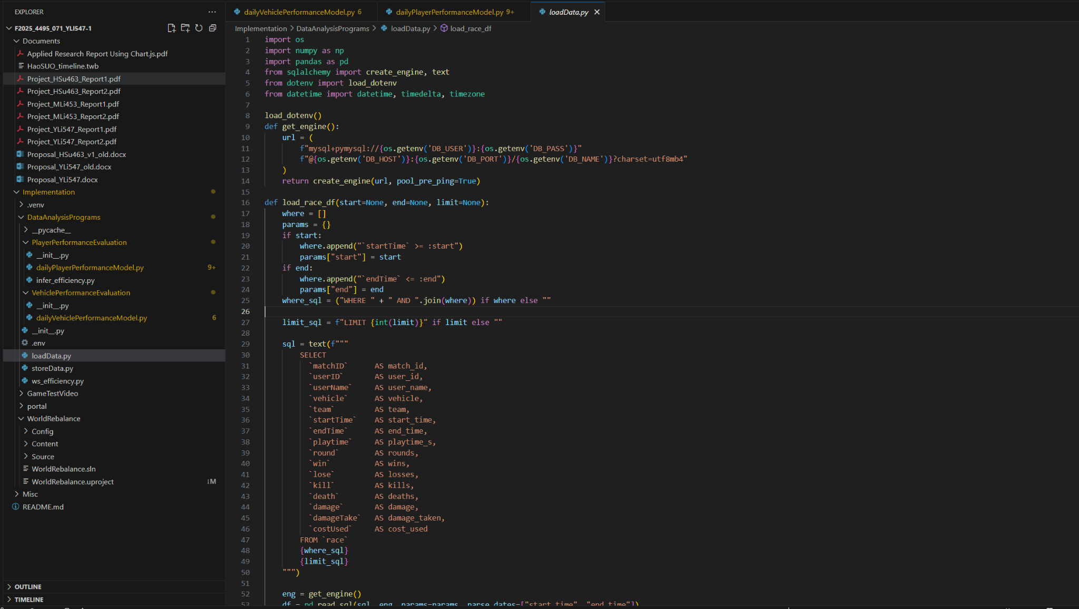

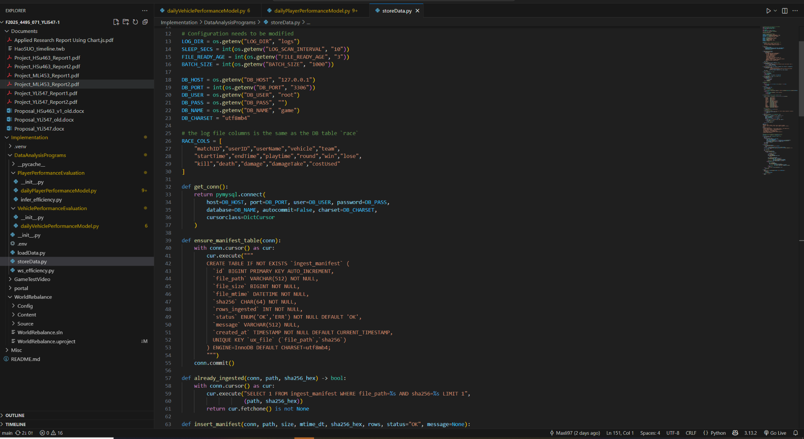

These two files read data from log file, load and store data from database.

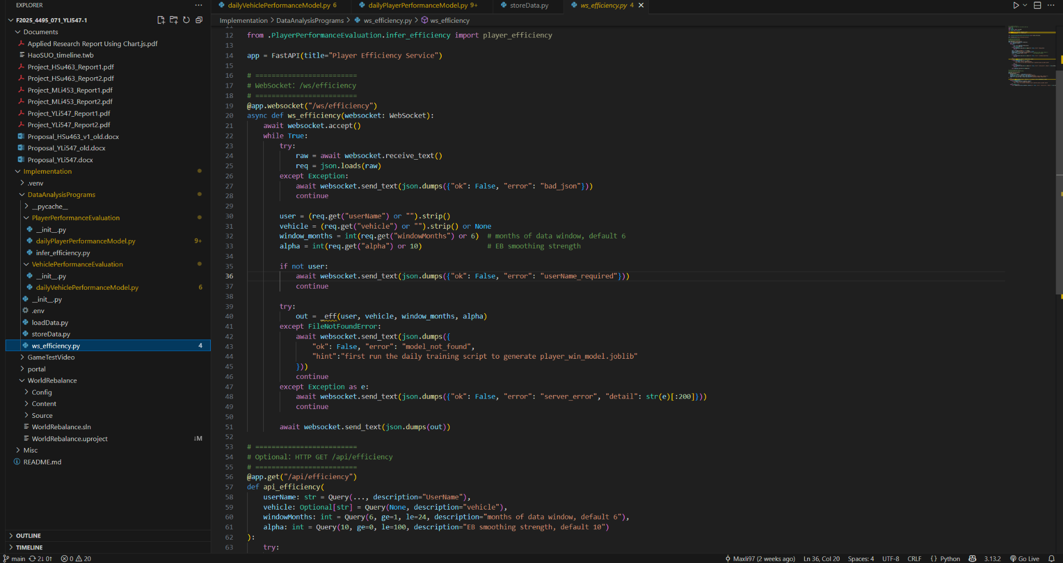

These codes are interfaces for websocket and http, but we will abandon these for now.

# Project Contract

Weekly Meeting: Thursday during the class break and Sunday afternoon via Zoom

Meeting Format: Review completed tasks, discuss blockers, and revise tasks as needed

Communication: Whatsapp for daily updates, email for formal discussions

Workflow: Tasks are assigned and tracked through the schedule tab in the group’s Google Doc

Contributions: spend at least 10 hours/week to finish assigned tasks and reports

We, the undersigned, agree to the above terms and commit to our responsibilities.

Hao SUO Yaolong Liu Muye Li





_______________ ______________ _______________

# 

# 

# 

# Work Logs

## Hao SUO

| **Date** | **#Hours** | **Description of Work Done** |
| --- | --- | --- |
| Sep 07, 2025 | 1 | Reviewed the document *General Guidelines and Deliverables* provided by the instructor |
| Sep 08, 2025 | 3 | Reading the *A Guide to Technical Report Writing* to be familiar with the rules |
| Sep 08, 2025 | 2 | Drafted the proposal for my part of the project, which focuses on the development of the website portal for displaying and analyzing game data |
| Sep 09, 2025 | 3 | Worked on project planning and created the Gantt chart for the website portal tasks using Tableau. Updated the proposal with the timeline section. |
| Sep 11, 2025 | 6 | Compared different data visualization libraries and finalized Chart.js as the choice. |
| Sep 12, 2025 | 2 | Revised the project proposal based on instructor’s feedback, including unifying the narrative perspective, adding detailed deliverables, and correcting tense and grammar issues in the report. |
| Sep 13, 2025 | 3 | Discussed data structure issues with teammates, finalized basic tables and related columns, and aligned on game mechanics and design approach. |
| Sep 15, 2025 | 4 | Researched server options for handling game data uploads; compared multiple online server providers but have not finalized the choice yet. |
| Sep 18, 2025 | 4 | Set up the basic environment with PHP and MySQL database; used local resources temporarily since the server has not been finalized. |
| Sep 20, 2025 | 1 | Revised the project proposal again, reorganized the Deliverables section for clarity and detail. |
| Sep 22, 2025 | 3 | Discussed data structure with teammates, confirmed the columns of the match table, and analyzed how the portal should retrieve data and the basic API design. |
| Sep 25, 2025 | 2 | Revised GitHub repository settings based on instructor’s requirements; renamed repository and updated README.md file accordingly. |

## Yaolong Liu

| **Date** | **#Hours** | **Description of Work Done** |
| --- | --- | --- |
| Sep 07, 2025 | 5 | Created a test unreal project to learn ClientListener, ReplicatedAsset, Information synchronization. |
| Sep 08, 2025 | 2 | Learnt RPCs(Remote Procedure Calls) |
| Sep 09, 2025 | 4 | Redefine the game's worldview; Low-meshes in maya (GDI: 4 vehicles, Nod: 4 vehicles) |
| Sep 12, 2025 | 6 | Gamelog output; debug crush with build in unreal 5.6.1; change coding part from visual studio to Rider; Unsolvable crush in unreal 5.6.1, then switch to unreal 5.5.4. |
| Sep 13, 2025 | 4 | Setup new project, test LAN multiplayer connect. |
| Sep 14, 2025 | 8 | Learned using steam as the agent to hold a remote server. Add session create, join. Unsuccess with a multiplayer test in a remote environment. |
| Sep 15, 2025 | 4 | Text LAN and Remote connection. |
| Sep 17, 2025 | 4 | Not working in steam remote. Learnt online video: <https://www.youtube.com/watch?v=jc0COamYRm4&t=488s> |
| Sep 19, 2025 | 4 | Debug code for the remote connection. Still not working. |
| Sep 20, 2025 | 6 | Test Unreal Engine 5.2.1. Still blocked in the remote. Seems like the port block or the APP ID have some issue. |
| Sep 21, 2025 | 4 | Test Unreal Engine 5.6.1. A lot of new debugging issue with a raw project. And learnt: <https://www.youtube.com/watch?v=Pk_Ki8rV8Wo>  But still not working… |
| Sep 22, 2025 | 3 | Currently, the most reasonable issue is the APP IP, maybe I have to pay 100 US$ for it. So, I plan to pause the remote connection and redebug it(or to pay for the IP) after we finish all the other mechanisms. Focus on LANconnection. Cleaned the working project and started to learn to replicate assets. |
| Sep 24, 2025 | 3 | Learned to find the reason why our lab computers cannot connect each other: the NetConnection -Port 7777 failed.  Reconnect the listen level and build focus ip connection. Finally in our prototype all the lab computers can connect to each other now! |
| Sep 26, 2025 | 5 | Replicate assets in C++, contribute to a two-player interactive gameplay. |
| Sep 27, 2025 | 4 | Player basic movement: walk, jump, couch. |
| Sep 28, 2025 | 5 | Animation blend and Montage for the camera scrolling up, down, left and right. |
| Sep 29, 2025 | 5 | Mesh shadowing bug fix: add the same body mesh that has a shadow rendering issue (one for server camera rendering, another one for client with no shadow, but the body with animation does not often match), use only one mesh, move the camera to the suitable position. Movement speed fixed. |
| Oct 1, 2025 | 3 | Player spawn points function setup. Player could select team and spawn in the correct camp. Login Widget (UI) to let player pick a camp. |
| Oct 3, 2025 | 3 | Pistol and rifle animations for player animation blueprint (including walk, run, jump and crouch). Weapon Library to find the correct name then to link to its relative asset’s path. |
| Oct 4, 2025 | 4 | Weapon actor setup. Player overlapping a weapon to pickup the weapon entity. |
| Oct 5, 2025 | 5 | Loot weapon in primary inventory and secondary inventory. A long debug with contact a weapon entity to become a looted weapon, then get the weapon info to trigger the correct player animation. The weapon actor loses physics to find the position of a socket (Player’s hand). If primary inventory is not null do not pick. If secondary inventory is null can only pick a pistol. |
| Oct 6, 2025 | 4 | Drop the equipped weapon. Weapon actor has physic and detaches the socket. |
| Oct 8, 2025 | 4 | Weapon switch, generate shooing trace line. Figure out the delay for check the array of inventory if it is not the same weapon and primary one or secondary one. |
| Oct 10, 2025 | 4 | Health and Armor can be damaged from other players, with UI update. |
| Oct 11, 2025 | 3 | Team management the game scope. In the game, I will focus on the tank combat and output data for other teammates. |
| Oct 12, 2025 | 4 | In FPS (First Person Shooter), Players respawn in seconds after their death. |
| Oct 13, 2025 | 4 | Win and lose condition; add team marks on UI. |
| Oct 15, 2025 | 6 | Debug weapon drop, respawn players after a battle round. |
| Oct 17, 2025 | 5 | Vehicle part meshes are added into the engine; C++ with the Tank class, Player controller, Turret and Barrel. |
| Oct 18, 2025 | 7 | The rotation of the turret and barrel with crosshair aiming. Turret has the rotation delay of the movement with FindDeltaAngleDegrees. Add firing system with SuggestProjectileVelocity which could give the projectile move as a parabola path. |
| Oct 19, 2025 | 5 | Basic Movement with TankTrack class (used for wheel meshes for now). Basic AI follows and damages the player. |
| Oct 20, 2025 | 4 | Movement physics update with correction acceleration. |
| Oct 22, 2025 | 4 | Projectile rebuild with FX and lifespan and area-force; Hit damage to other actors. |
| Oct 24, 2025 | 4 | Vehicle health and UI setup. |
| Oct 25, 2025 | 2 | Report 3, midterm report document. |

## Muye Li

| **Date** | **#Hours** | **Description of Work Done** |
| --- | --- | --- |
| Sep 7, 2025 | 2 | Discuss about the project proposal. |
| Sep 12, 2025 | 2 | Drafted the proposal of the project. |
| Sep 13, 2025 | 2 | Made detail plan about timeline and the function of the part I am responsible for. |
| Sep 19, 2025 | 2.5 | Decide on database structure, discuss data transfer methods, edit the project proposal. |
| Sep 20, 2025 | 1.5 | Testing multiplayer functionality |
| Sep 21, 2025 | 3 | Testing multiplayer functionality |
| Sep 27, 2025 | 4 | Completed some of the code for user vehicle evaluation |
| Oct 3, 2025 | 2 | Finish get data from MySQL |
| Oct 4, 2025 | 4 | Finish Daily Player performance model |
| Oct 8, 2025 | 3 | Finish Change feature function and edit model |
| Oct 9, 2025 | 4 | Finish Daily Vehicle performance model |
| Oct 10, 2025 | 4 | Finish WebSocket/http connection, try to run multiple files at the same time. |
| Oct 11, 2025 | 3 | Discuss with teammates about server, function change, database change. |
| Oct 13, 2025 | 1 | Create new tables in the database. |
| Oct 14, 2025 | 3 | Change vehicle performance model |
| Oct 18, 2025 | 4 | Create a new python file to read log file and store in database |
| Oct 24, 2025 | 2 | Prepare for midterm report |
| Oct 25, 2025 | 3 | Finish midterm report, discuss about project timeline |

# 

# 

# 

# 

# 

# 

# 

# Implemented Feature 4: Game Project

## Overview

A multiplayer game could play as the mode of First Person Shooter, while in the main combat, players could drive vehicles to win the battle.

The game project is made with Unreal Engine 5.5.4.

The trooper mode is made by Blueprint.

The vehicle mode is made by C++.

## Game Concept

| **Camp-Nod** Raider Buggy |  |
| --- | --- |
| Pic 2 | Health: 100 |
| Speed: |
| Damage: |
| Rate of Fire: |
| Cost: |
|  |

| **Camp-Nod** Attack Bike |  |
| --- | --- |
| A black and white drawing of a motorcycle  AI-generated content may be incorrect.  Pic 3 | Health: 70 |
| Speed: |
| Damage: |
| Rate of Fire: |
| Cost: |
|  |

| **Camp-Nod** Scorpion Tank |  |
| --- | --- |
| Pic 4 | Health: 300 |
| Speed: |
| Damage: |
| Rate of Fire: |
| Cost: |
|  |

| **Camp-Nod** Flame weaponry |  |
| --- | --- |
| Flame weaponry - Command & Conquer Wiki - covering Tiberium, Red Alert and  Generals universes  Pic 5 | Health: 500 |
| Speed: |
| Damage: |
| Rate of Fire: |
| Cost: |
|  |

| **Camp - GDI** APC |  |
| --- | --- |
| APC (Tiberium Wars) - Command & Conquer Wiki - covering Tiberium, Red Alert  and Generals universes  Pic 6 | Health: 150 |
| Speed: |
| Damage: |
| Rate of Fire: |
| Cost: |
|  |

| **Camp - GDI** Pitbull |  |
| --- | --- |
| Pitbull (Tiberium Wars) - Command & Conquer Wiki - covering Tiberium, Red  Alert and Generals universes  Pic 7 | Health: 100 |
| Speed: |
| Damage: |
| Rate of Fire: |
| Cost: |
|  |

| **Camp - GDI** Predator Tank |  |
| --- | --- |
| Predator tank (Tiberium Wars) - Command & Conquer Wiki - covering ...  Pic 8 | Health: 700 |
| Speed: |
| Damage: |
| Rate of Fire: |
| Cost: |
|  |

| **Camp - GDI** Mammoth Tank |  |
| --- | --- |
| Рассказ об игре Command and Conquer 3: Tiberium Wars + История C&C. | Пикабу  Pic 9 | Health: 1500 |
| Speed: |
| Damage: |
| Rate of Fire: |
| Cost: |
|  |

## Our Mod

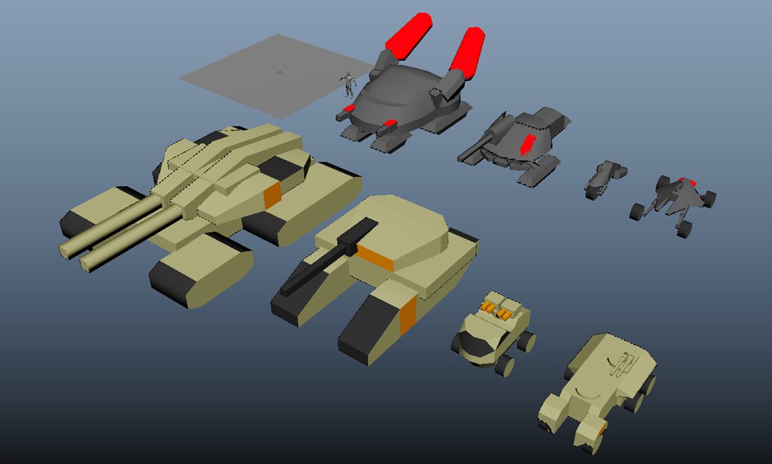

## Game Mechanism

| Character mechanism | Health, Walk, Run, Jump, Crouch, Aim, Shoot, Damage, Purchase Vehicle. |
| --- | --- |
| Light Vehicle mechanism | Drive, Accelerate, Gunshoot, Zoom lens rate, Damage, Steering speed. |
| Bike/Pitbull mechanism | Drive, Accelerate, Rocket, Zoom lens rate, Damage, Steering speed. |
| Tank mechanism | Drive, Accelerate, Rocket, Zoom lens rate, Damage, Steering speed. |

## Game Project

### Open our Game project:

**Engine Version**: make sure to download the same version: **Unreal Engine 5.5.4**

Video in:~\WorldRebalance\W_4495_S071_G_world-rebalance\Implementation\GameTestVideo\GameProjectSetupAndGameBuild.mkv

1. Right click the .uproject to Generate Visual Studio project files.

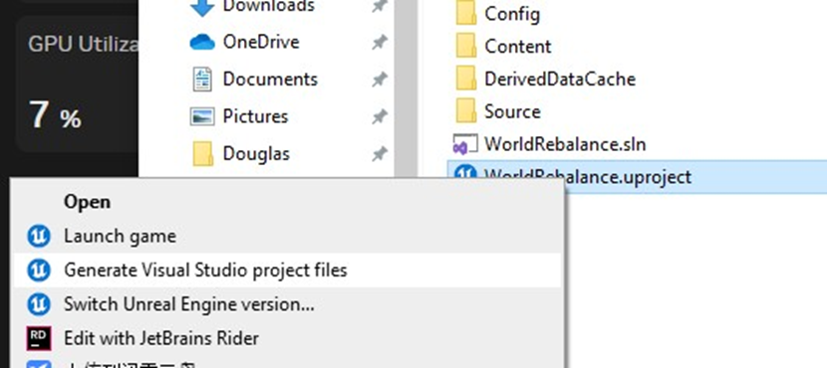

1. Rebuild the project.

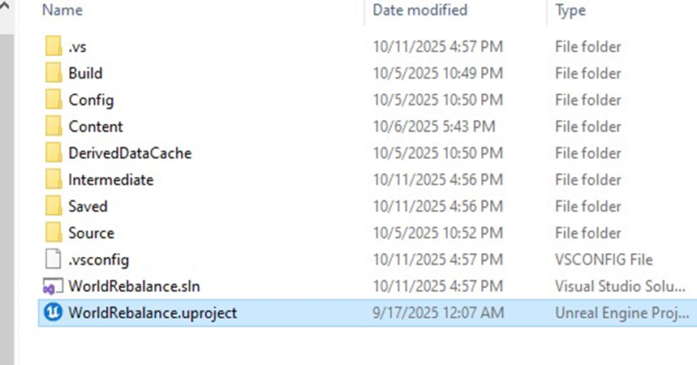

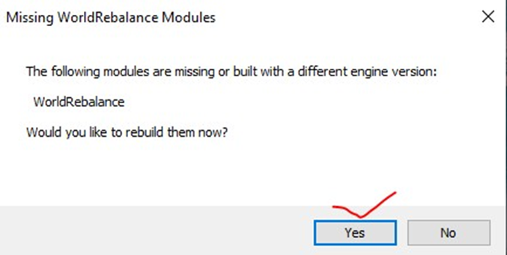



1. Once the window opens, need to build the C++ in Rider. (It is hard to build in Visual Studio, a lot of plugin errors there…)

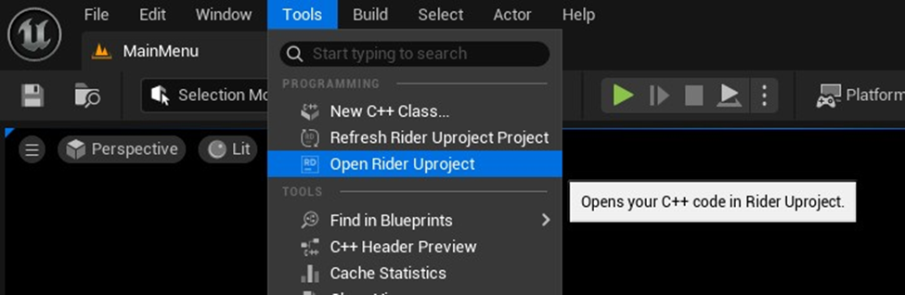

1. Build C++ in Rider. Must close the Unreal Engine before Build.

**Also, All C++ codes are here.**

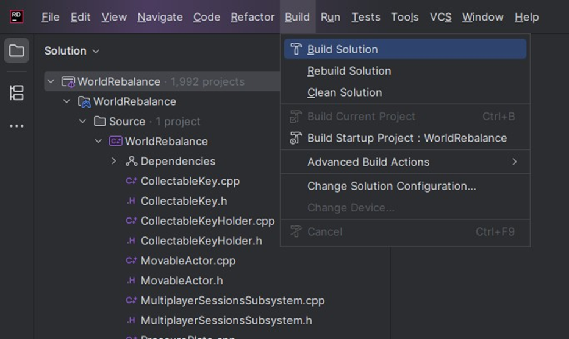

**In the Unreal Editor, all Blueprints are here:**

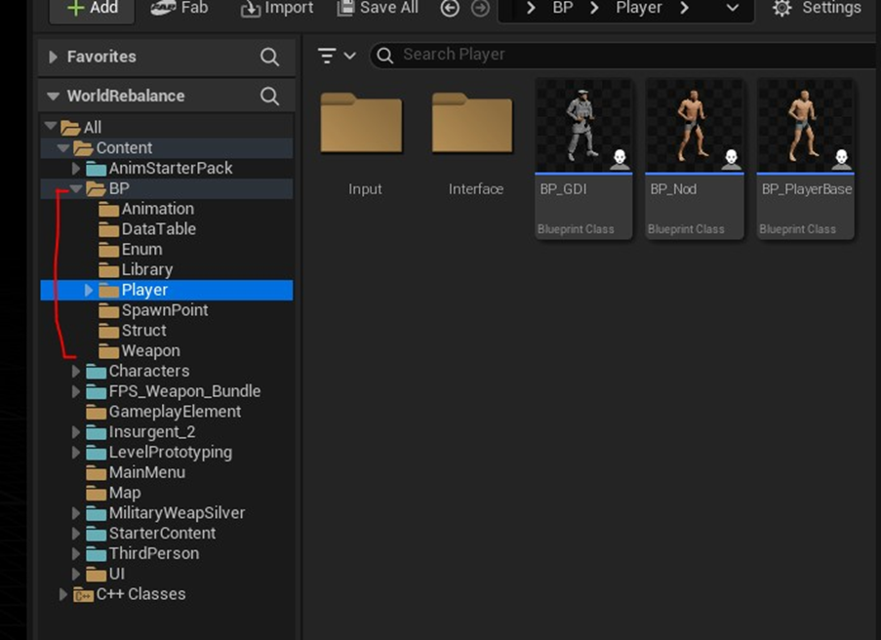

### 

### 

### 

### 

### 

### 

### 

### 

### 

### 

### 

### Code and Blueprint

#### Player code and Blueprint:

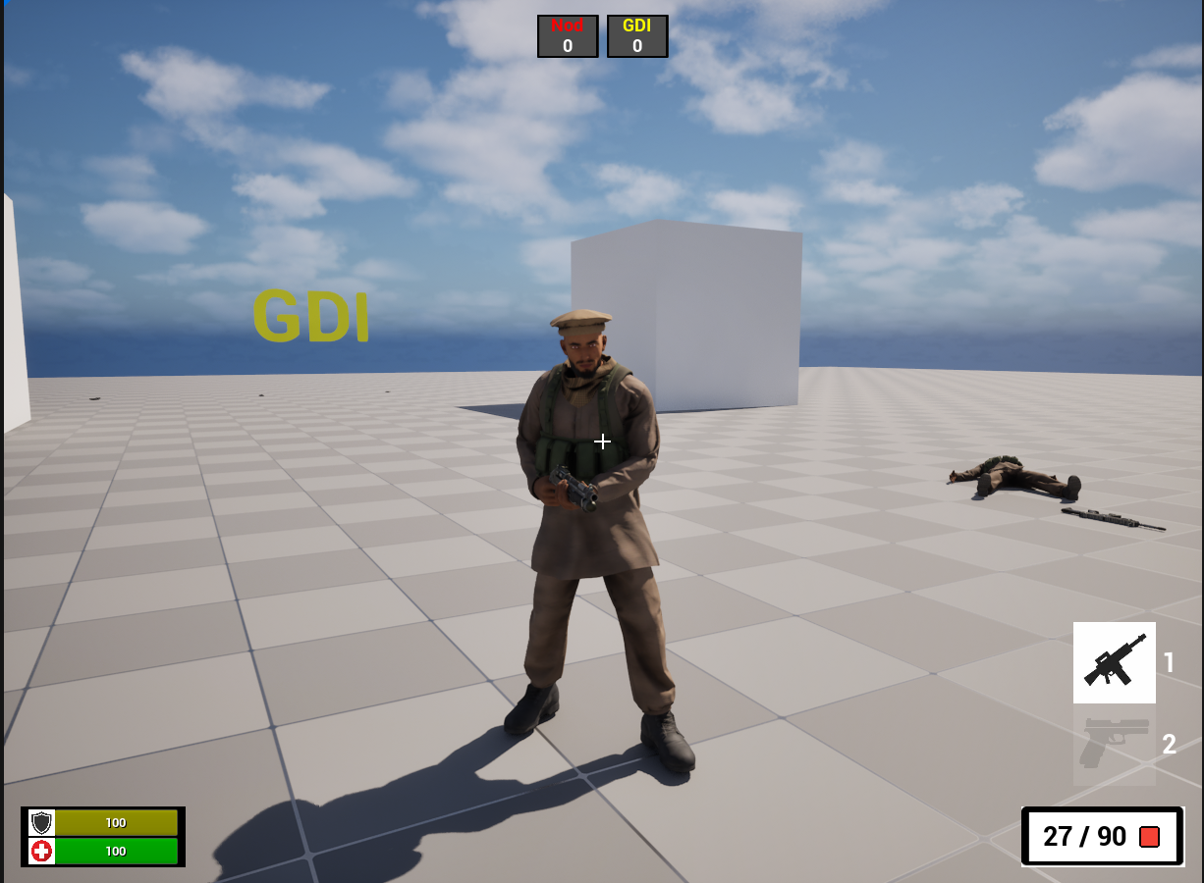

**Player Blueprint logic map:**

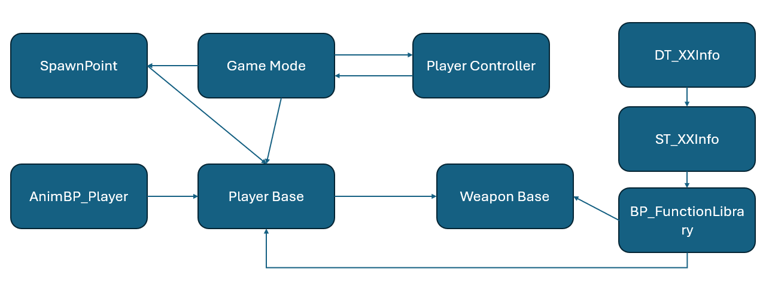

1. Root folder:

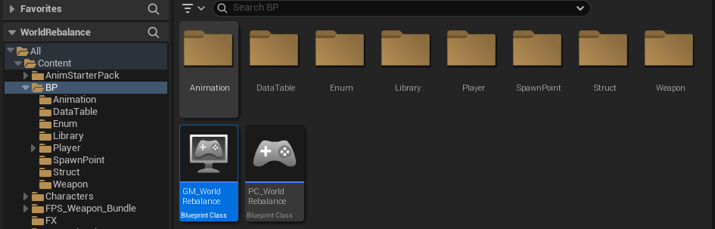

GameMode: When the level is started, spawn players, and find how many players are alive and dead. Then trigger the win condition.

/Script/Engine.Blueprint'/Game/BP/GM_WorldRebalance.GM_WorldRebalance'

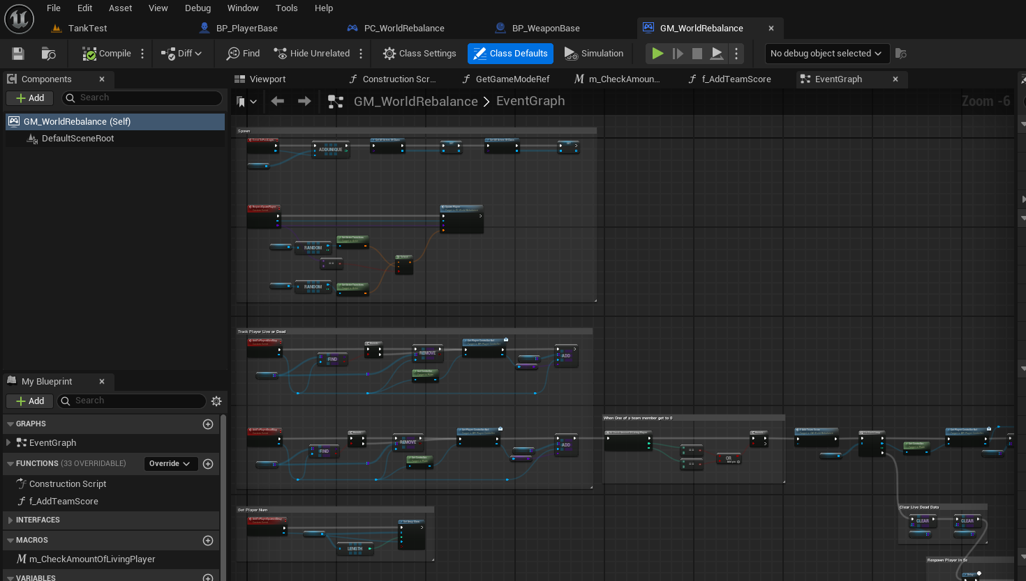

PlayerController: Connect GameMode to link to a real player to make conditions with his own widgets on and off, spawn, win or lose.

/Script/Engine.Blueprint'/Game/BP/PC_WorldRebalance.PC_WorldRebalance'

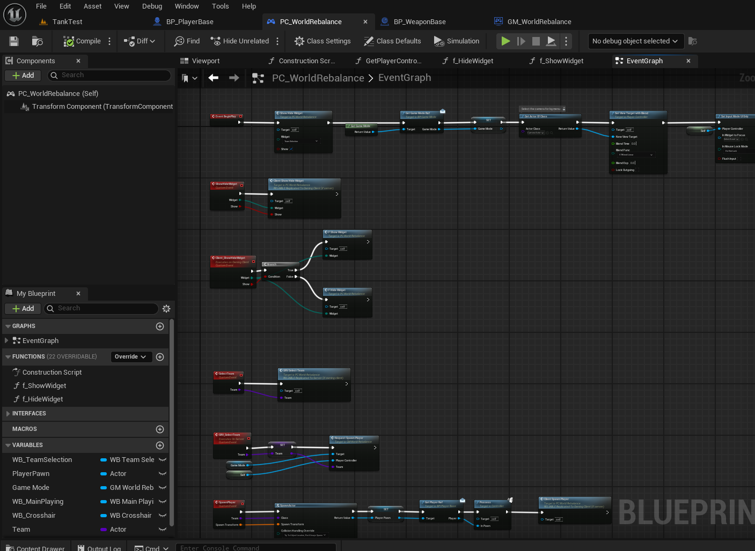

1. “Player” folder:

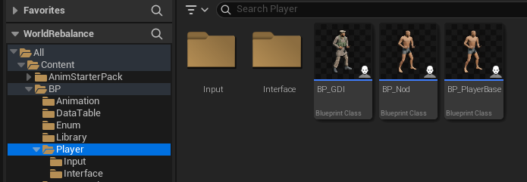

In the “Input” folder: Activity triggered by mouse and keyboard buttons.

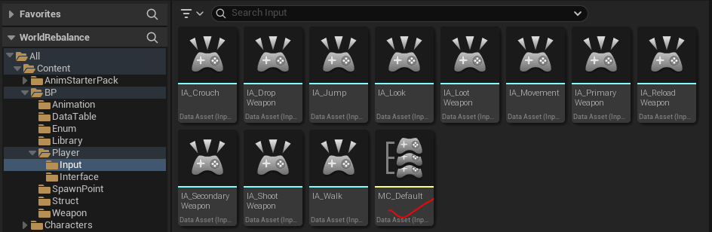

Interface to GetOwner().

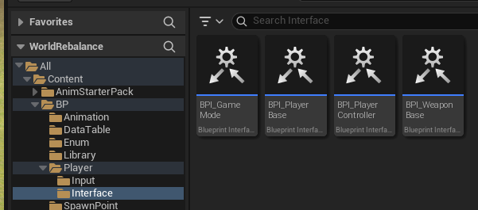

/Script/Engine.Blueprint'/Game/BP/Player/BP_PlayerBase.BP_PlayerBase'

In the EventGraph page: it includes the basic movement functions and health system.

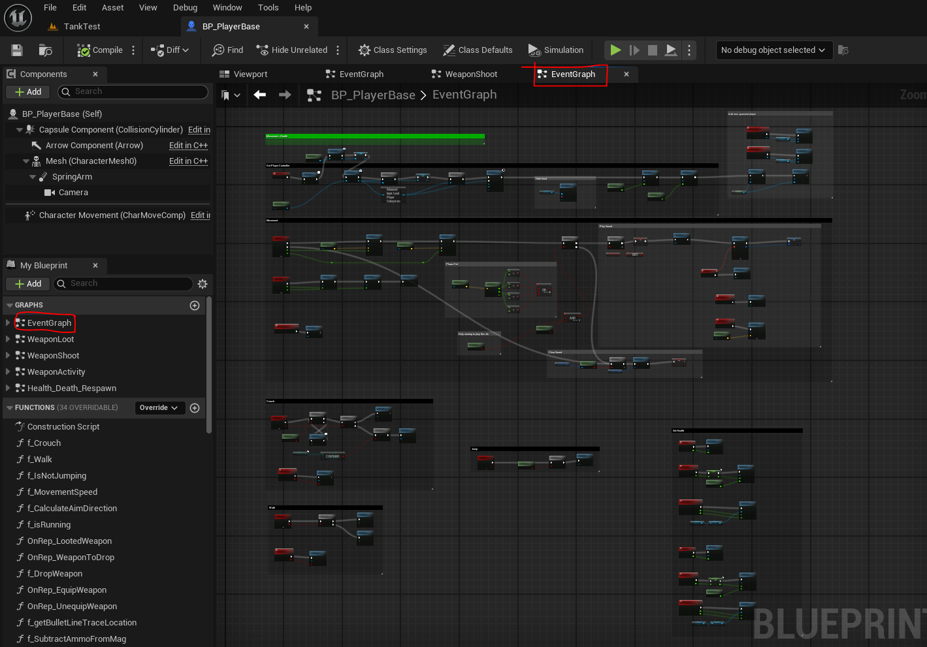

In the WeaponLoot page: it allow player to pick two weapons (Primary and Secondary)

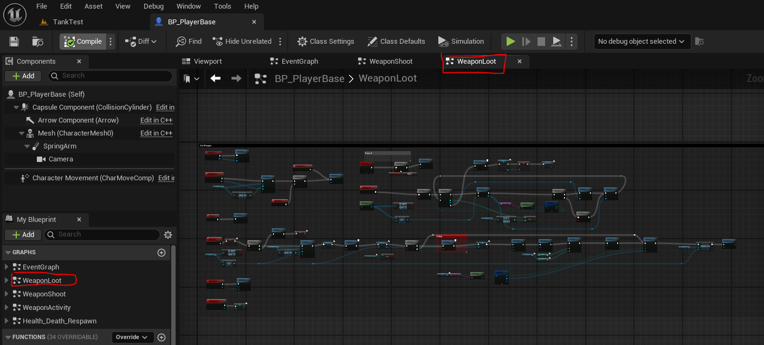

In the WeaponShoot page: Player can shoot and show the impact of other actors.

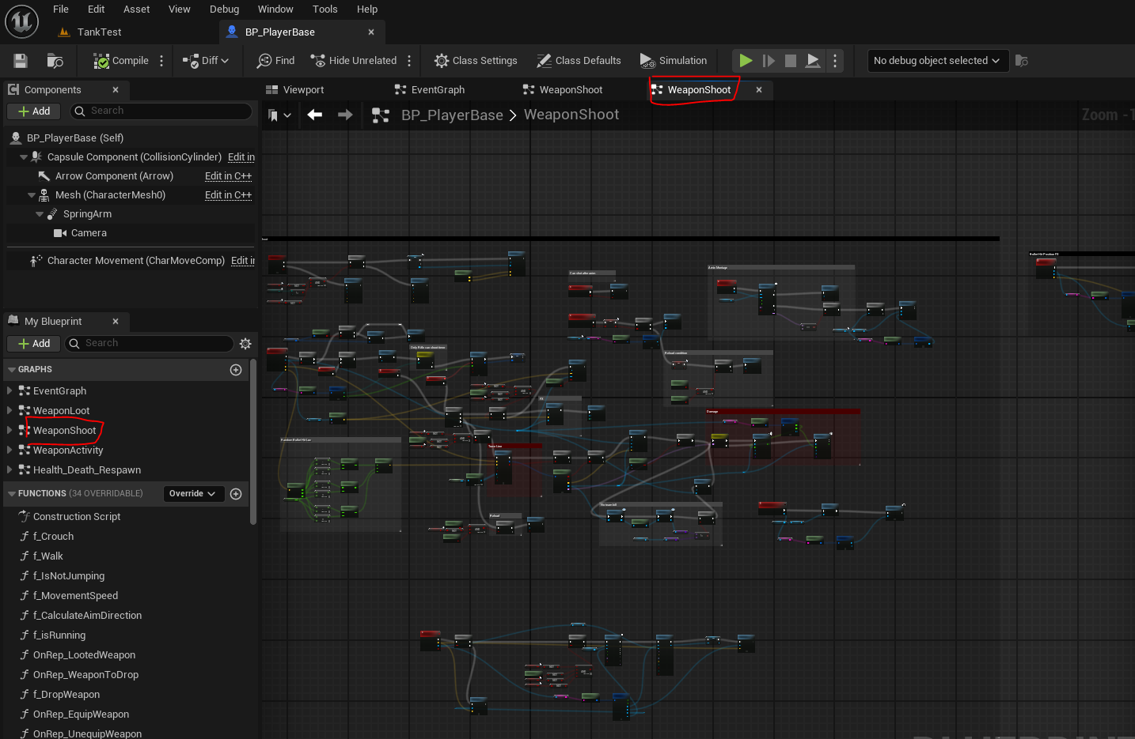

In the WeaponActivity page: including what player can do with the weapon (drop, switch, reload and calculate bullet account)

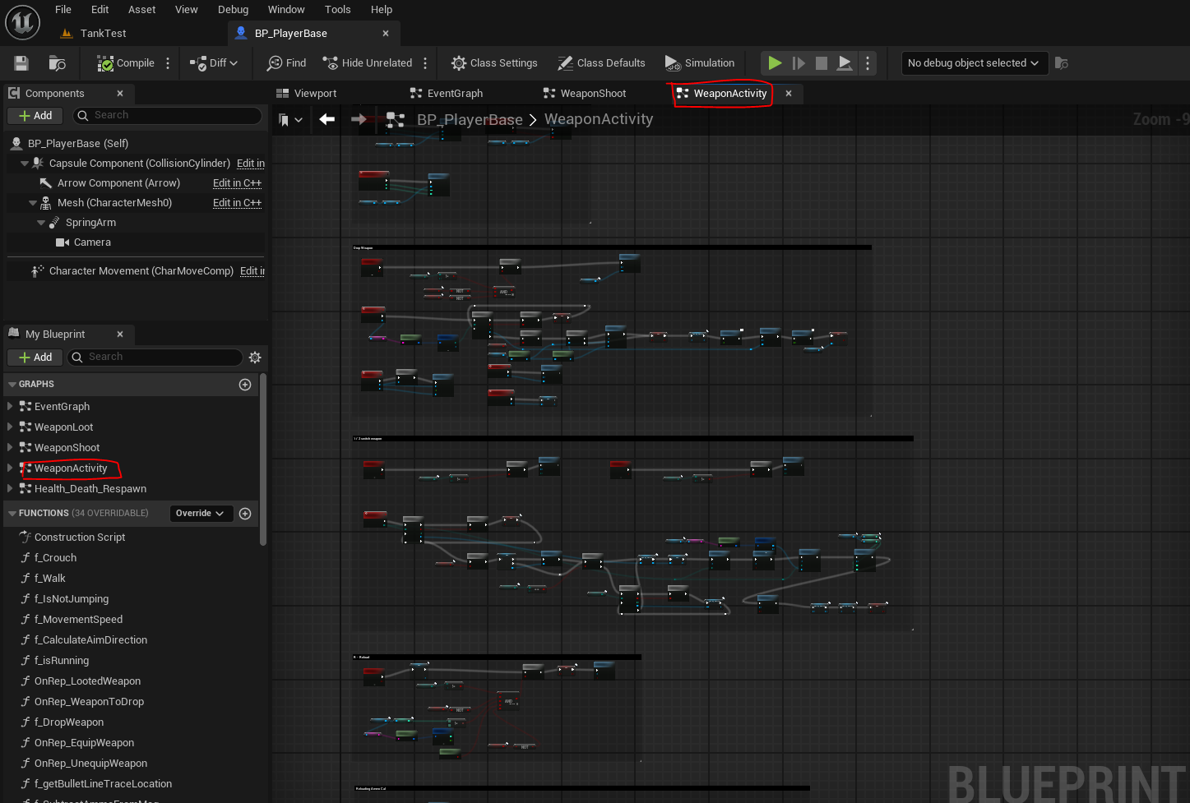

In the Health_Death_Respawn page: Player dead when health is 0. Respawn locations.

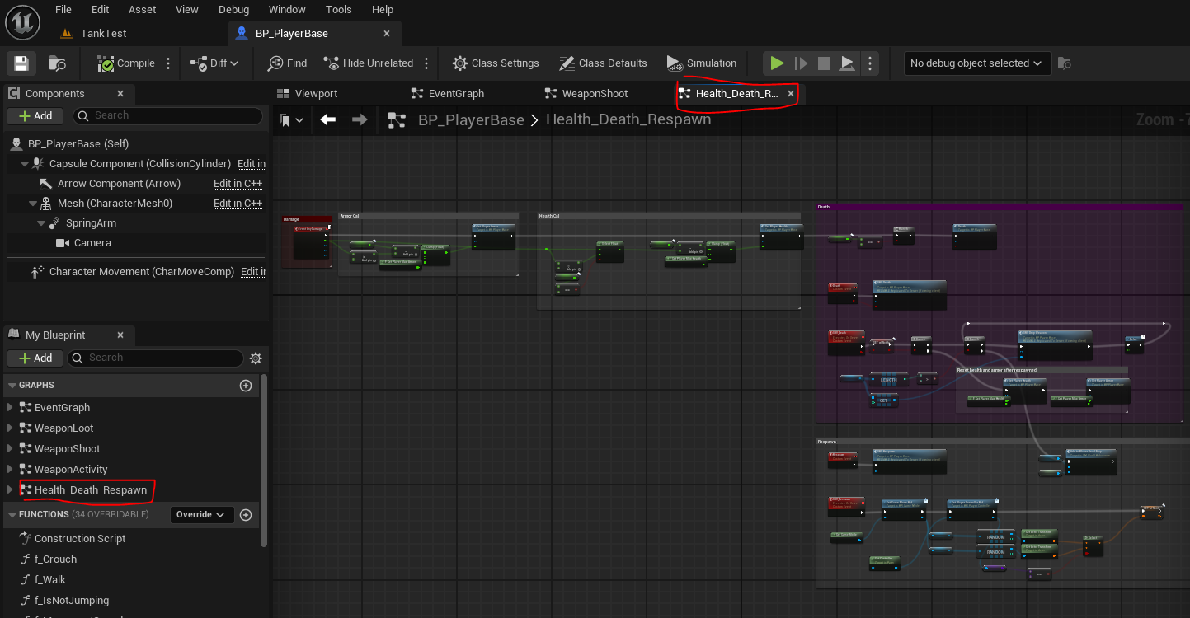

/Script/Engine.Blueprint'/Game/BP/Weapon/BP_WeaponBase.BP_WeaponBase'

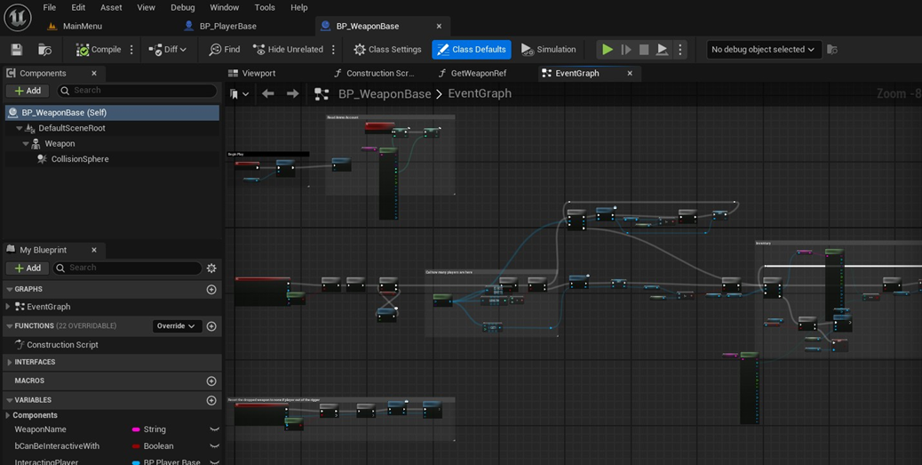

1. Animation folder:

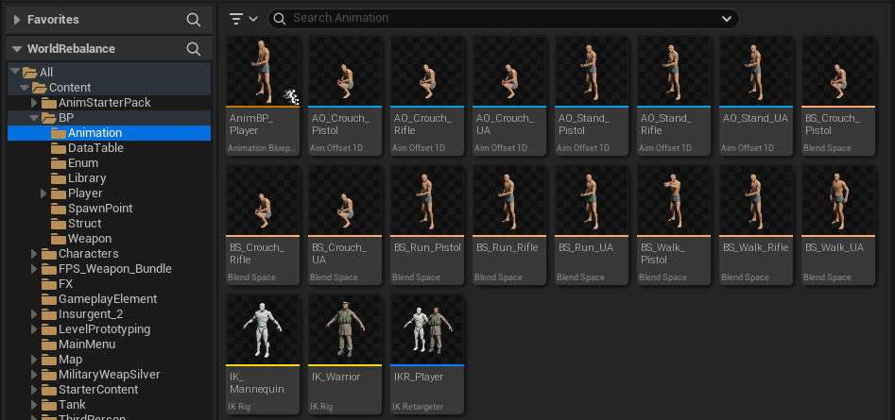

/Script/Engine.AnimBlueprint'/Game/BP/Animation/AnimBP_Player.AnimBP_Player'

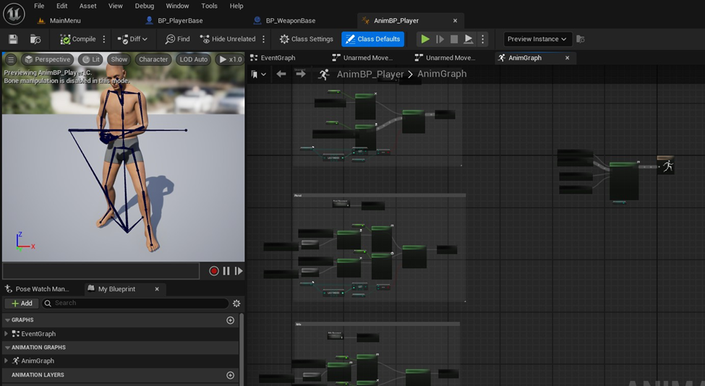

1. DataTable folder: can load a xlsx file with weapon attribute and player attribute. After blending with Struct (ST_PlayerInfo and ST_WeaponInfo) it could save the blueprint readable data It could save a lot of effort on the blueprint.

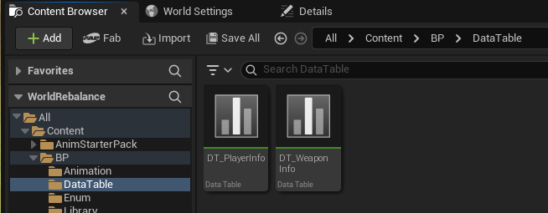

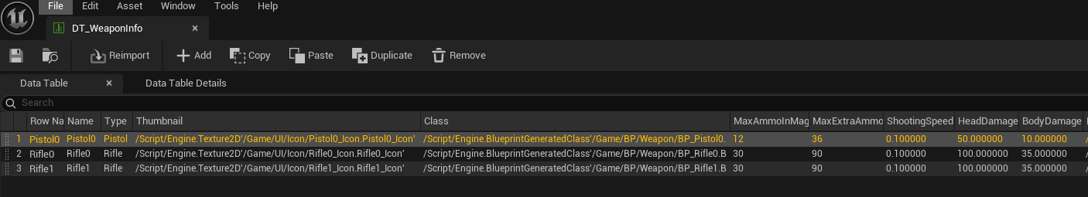

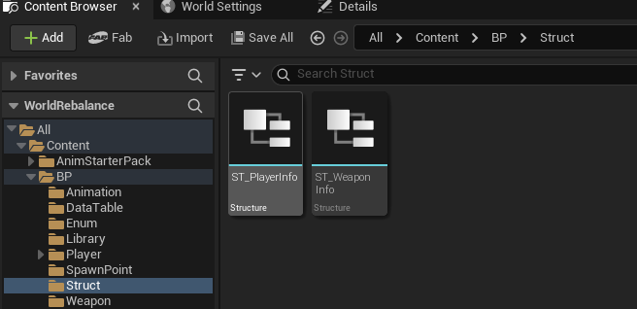

Then add a function library that is public to call from all the blueprint to get data.

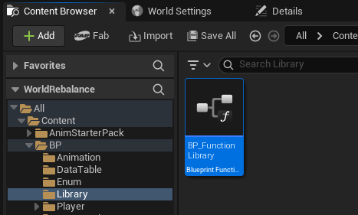

1. Enum folder: get types of names.

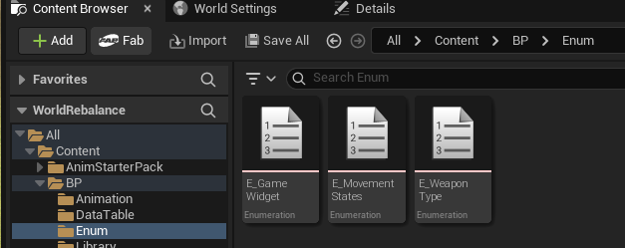

1. SpawnPoint folder: the spawn location actors.

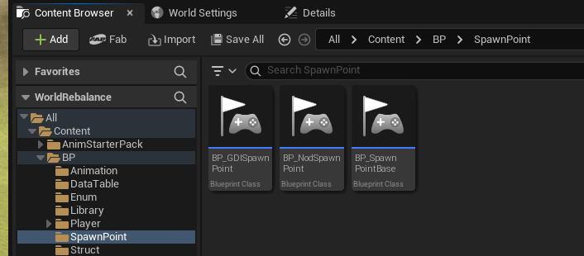

1. Weapon folder:

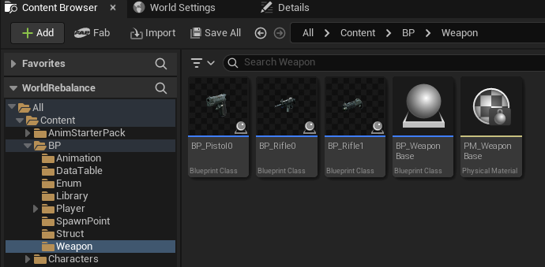

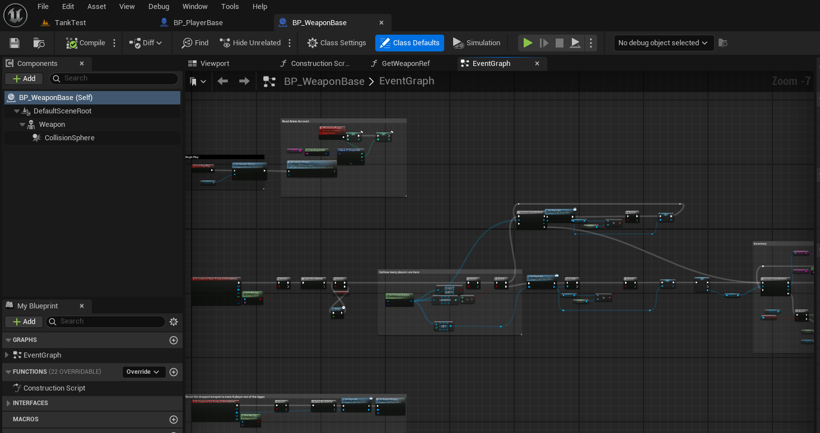

Trigger conditions.

#### Tank code and Blueprint:

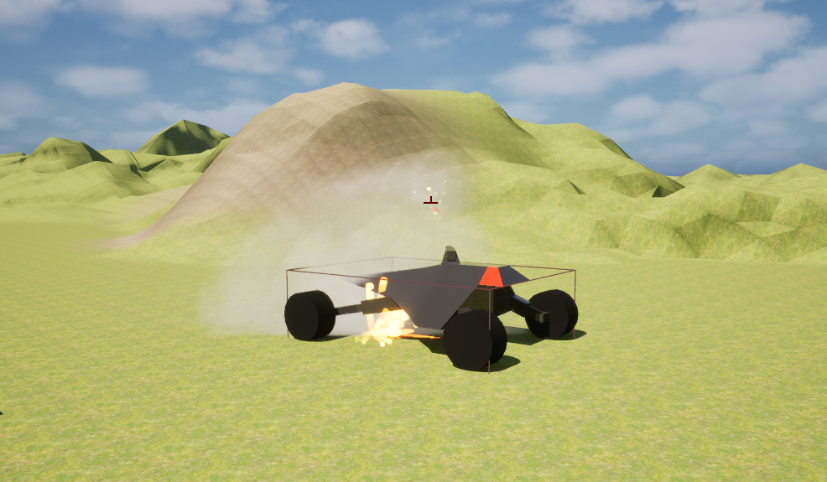

**Tank C++ logic map:**

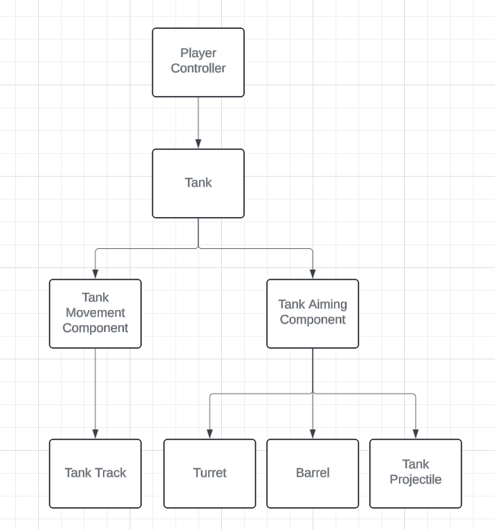

**Tank C++:**

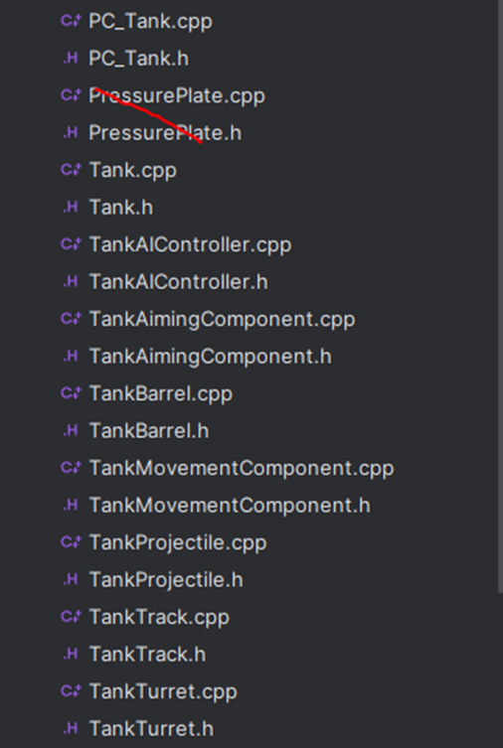

.h: announcement file

.cpp: c++ working file

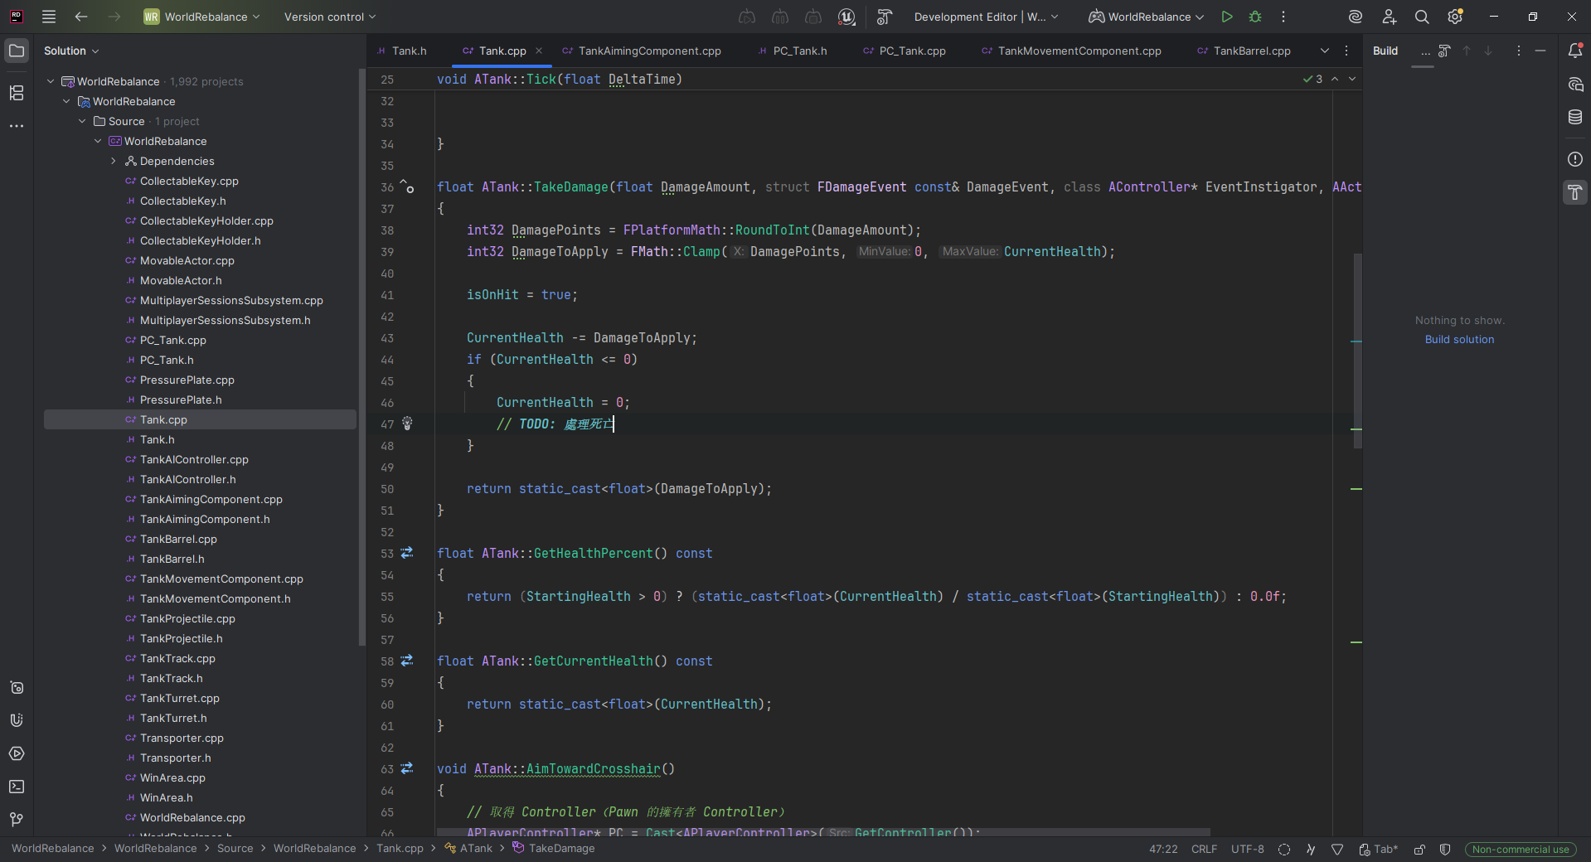

## Maps in the Editor

/Script/Engine.World'/Game/Map/Battle1.Battle1'

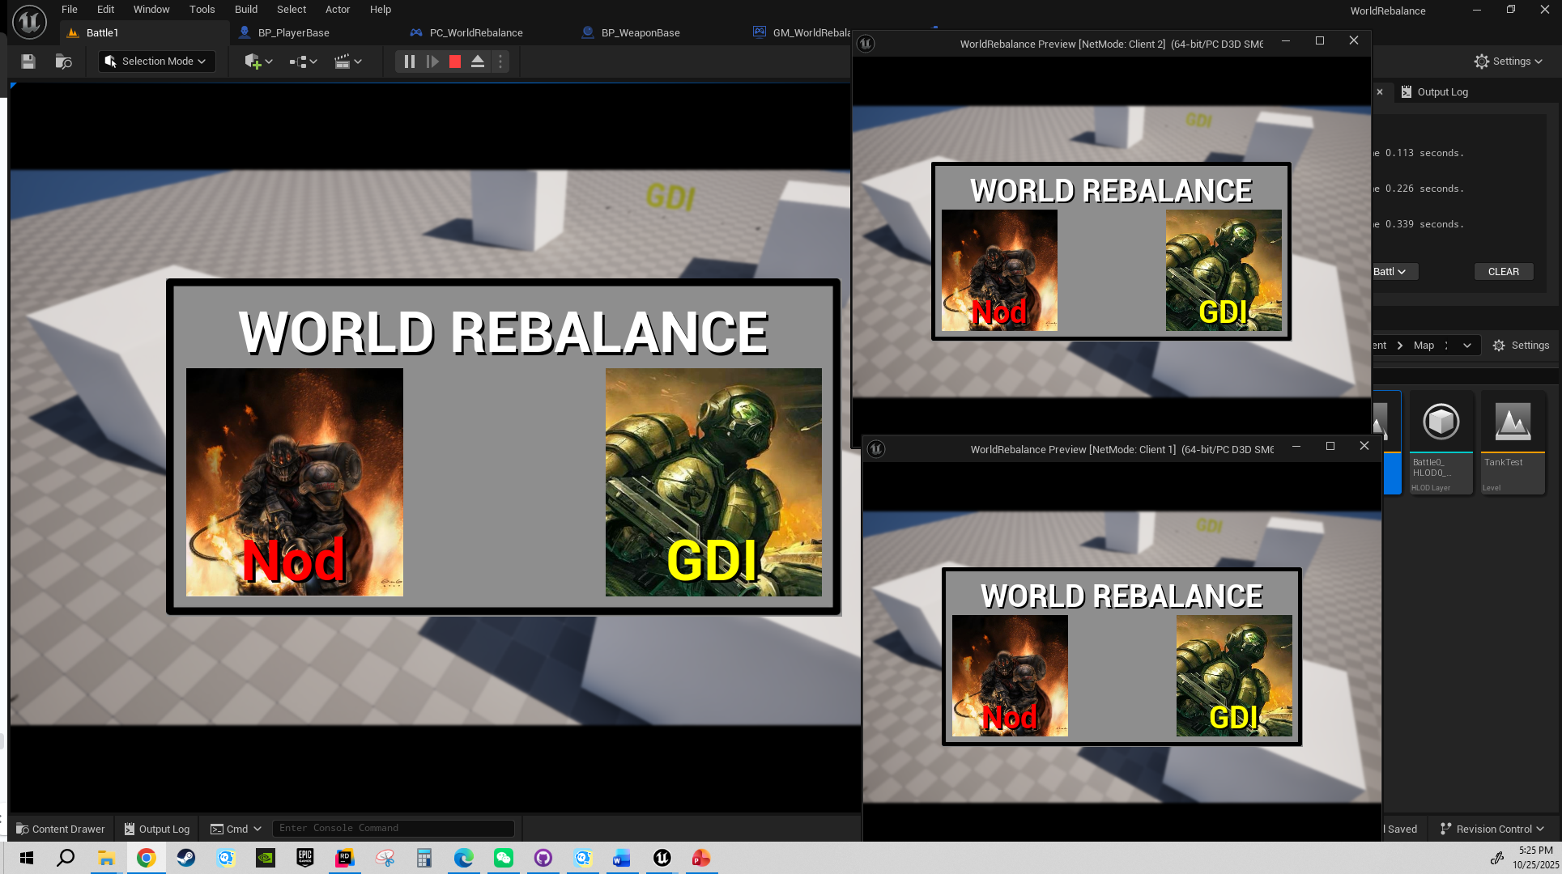

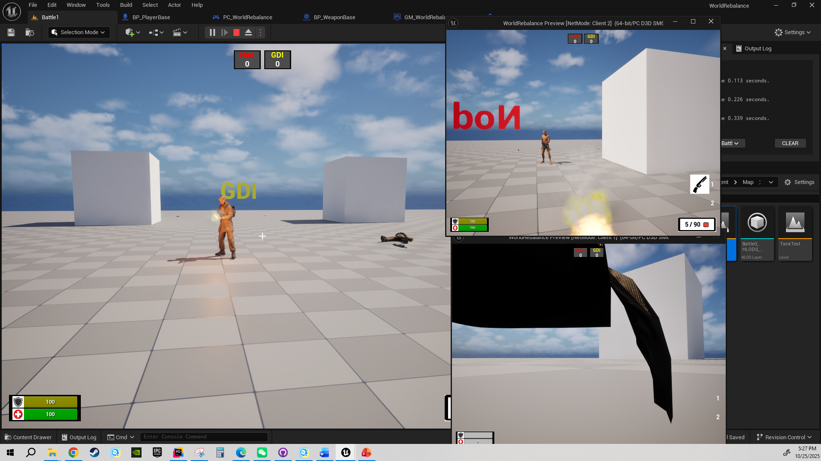

/Script/Engine.World'/Game/Map/TankTest.TankTest'

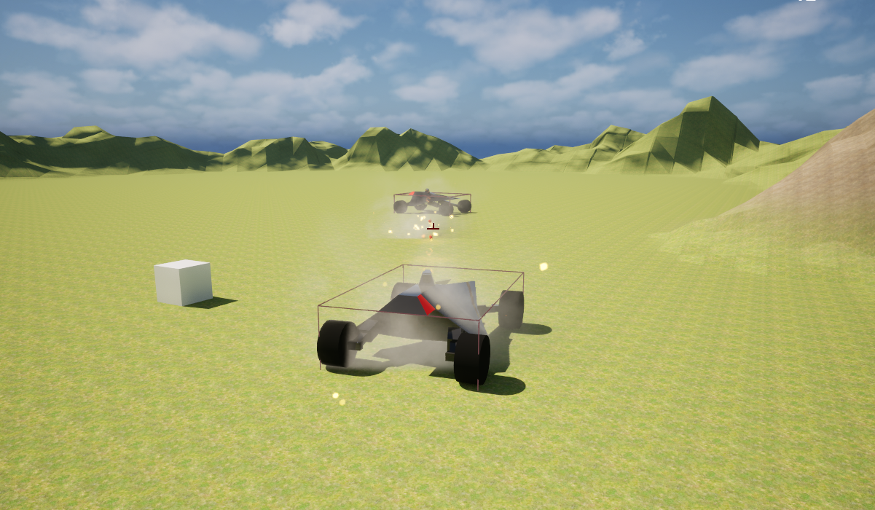

## Play our Game

### In Unreal Editor:

1. Open the correct level.
2. Set the number of players and use Liston Server.

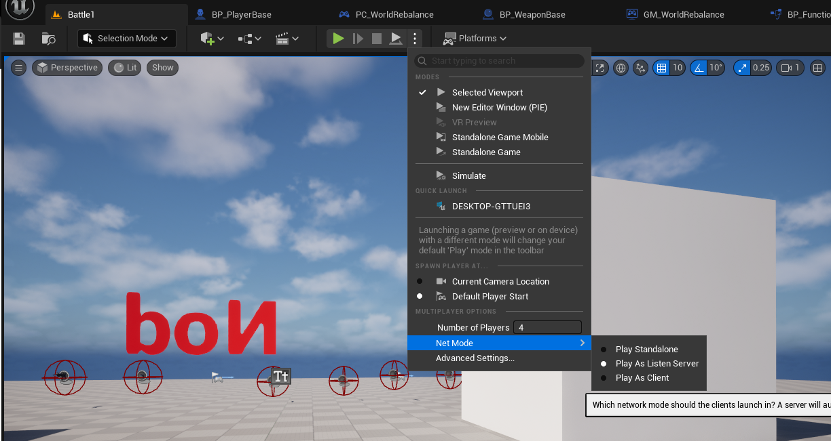

1. Play this level.

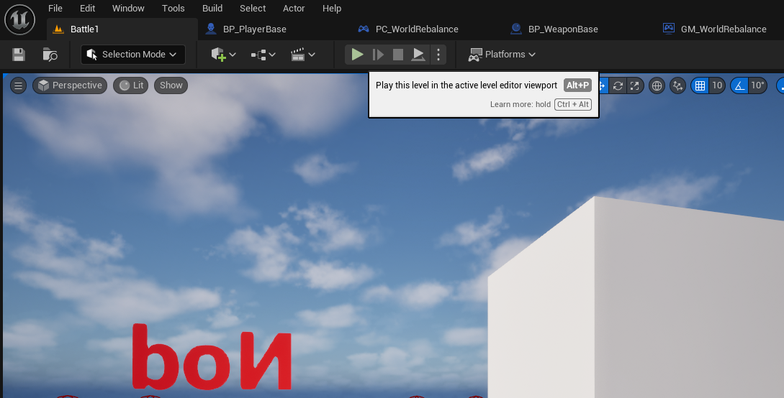

1. In the tankTest mode, it currently does not support multiplayer.

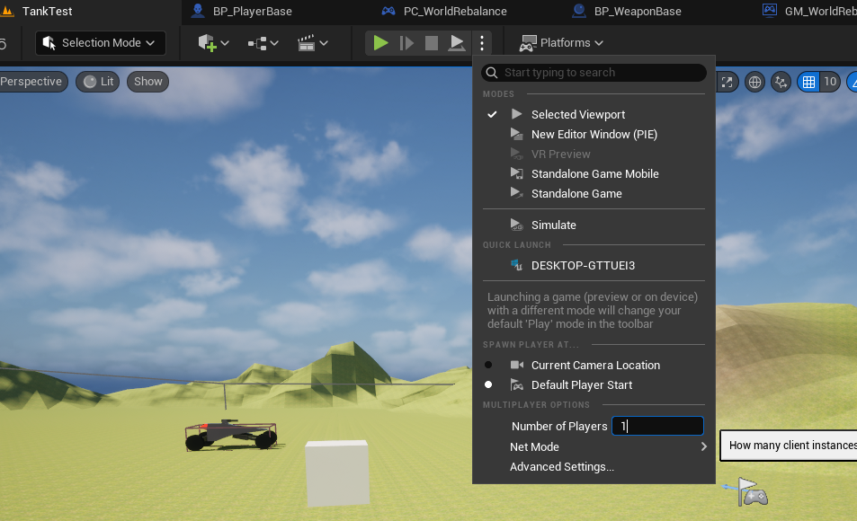

**Or**

### In the Build Output:

Build the game as a shipped one.

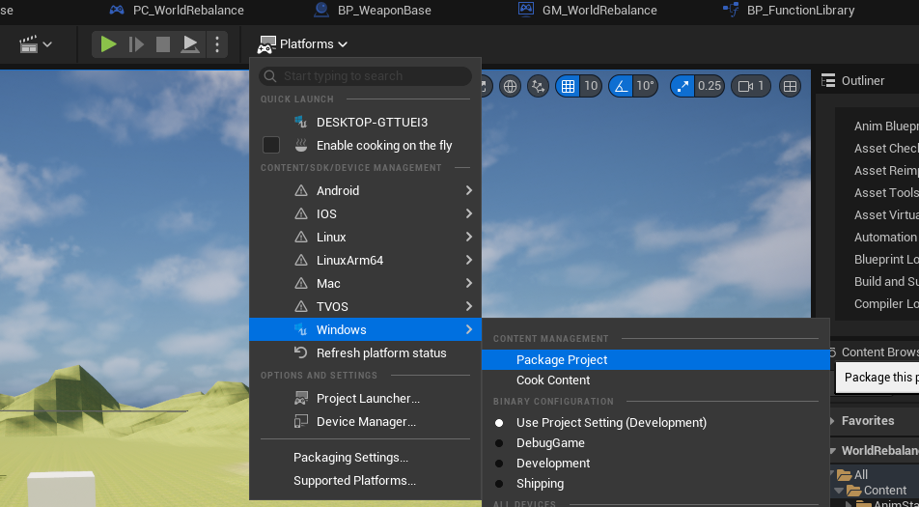

Make a folder to output the build.

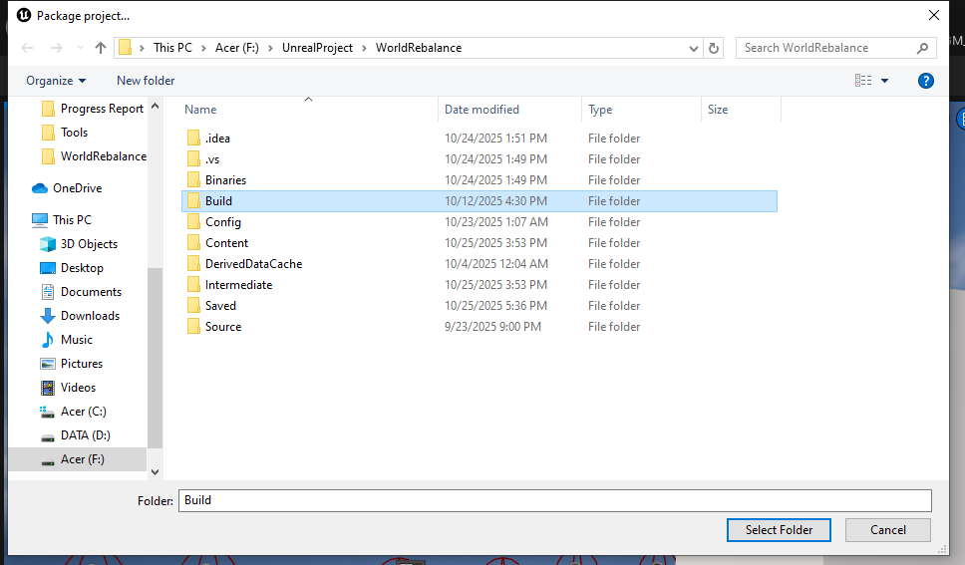

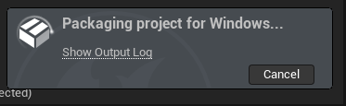

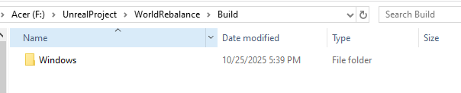

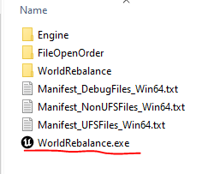

If User want to play in our campus computer please:

Extract the zip on Desktop. (C:\Users\300380547\Desktop\Windows\Windows)

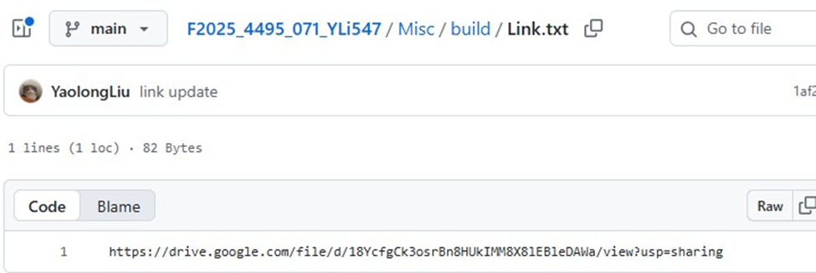

Misc/build/Link.txt [https://drive.google.com/file/d/18YcfgCk3osrBn8HUkIMM8X8lEBleDAWa/view?usp=sharin g](https://drive.google.com/file/d/18YcfgCk3osrBn8HUkIMM8X8lEBleDAWa/view?usp=sharing)

**If in a campus lab**: *server.bat*: Misc/build/server.bat

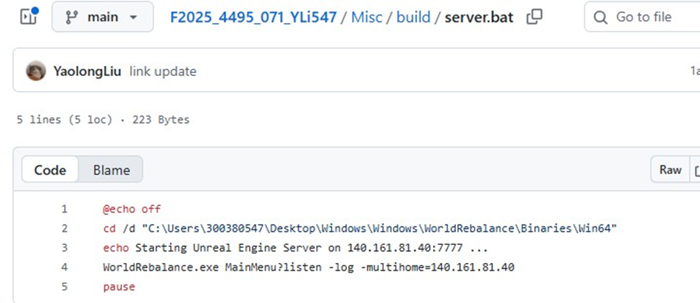

Need to add *server.bat* in the root folder and make sure the IP is the local IP.

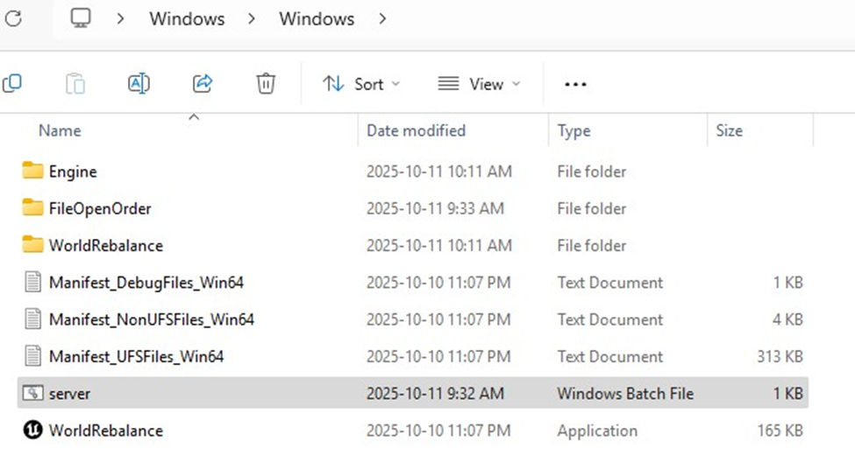

*client.bat*: Misc/build/client.bat

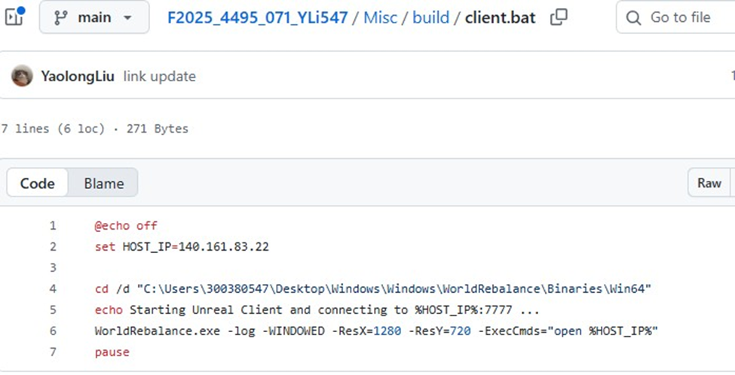

Need to add *client.bat* in the root folder and make sure the same IP as the server’s.

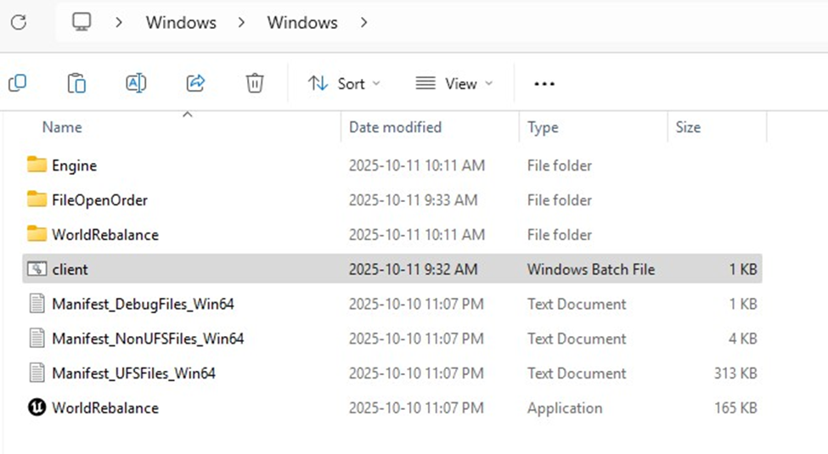

# Reference

Command & Conquer 3: Tiberium Wars.(2025) *wiki*. <https://en.wikipedia.org/wiki/Command_%26_Conquer_3:_Tiberium_Wars>

This is What Really Gets Me in This Game. (2025) *reddit.* <https://www.reddit.com/r/Battlefield6/comments/1mmprww/this_is_what_really_gets_me_in_this_game/>

Raider Buggy. *Command & Conquer Wiki* [Photograph]. <https://cnc.fandom.com/wiki/Electromagnetic_pulse_weaponry?file=Raider_Buggy.jpg>

SDW 391010. *Desktop Wallpapers - Command And Conquer 3 Tiberium Wars C&C3* [Photograph]. <https://wallpaper-house.com/wallpaper-id-391010.php>

Nod Armor - C*ommand and Conquer - Tiberium Lore* [video]. <https://www.youtube.com/watch?v=CEmWzZMwWrQ>

CNCTW Guardian APC Cameo. *Command & Conquer Wiki* [Photograph]. <https://cnc.fandom.com/wiki/APC_(Tiberium_Wars)?file=CNCTW_Guardian_APC_Cameo.png>

CNCTW Pitbull Cameo. *Command & Conquer Wiki* [Photograph]. <https://cnc.fandom.com/wiki/Pitbull_(Tiberium_Wars)?file=CNCTW_Pitbull_Cameo.png>

Predator Tank with testing decal. *MBT-6 Predator* [Photograph]. <https://the-wolfenstein-fanon.fandom.com/wiki/MBT-6_Predator?file=Predator_Tank_with_testing_decal.jpg>

Command and conquer likes double barreled tanks (2021) [Photograph]. <https://www.reddit.com/r/commandandconquer/comments/tv1dmv/command_and_conquer_likes_double_barreled_tanks/>

# Appendix

## 1 Applied Research Report Using [Chart.js](http://chart.js)

This appendix includes notes and experiments from my research on using Chart.js for data visualization and connecting it with a MySQL database through PHP.

I tested how to fetch data dynamically using AJAX and display it in real time on different chart types, such as bar and line charts.

The study also explored how to handle JSON data returned from PHP scripts and update chart datasets when new records are added to the database.

The full report and example code have been uploaded to my GitHub repository for reference.

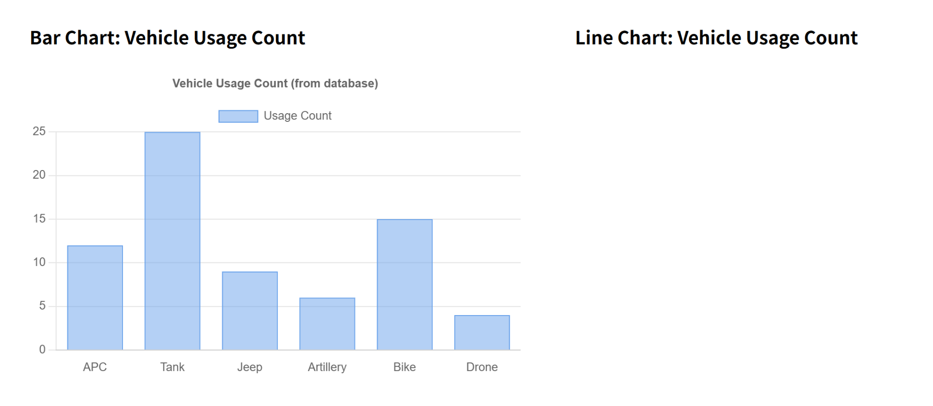

## 2 Applied Research report interaction with [Chart.js](http://chart.js)

This appendix includes notes and test results from my research on Chart.js interactivity. I tested how multiple charts can be linked by conditions and how to update datasets efficiently when user selections change. The full document has been uploaded to my GitHub repository for reference.

